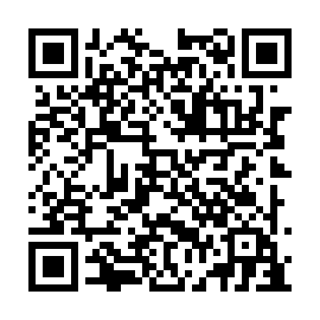
Prayer times for St. Andrews Channel, Nova Scotia, Canada
Mon 1 Jul 2024 - Wed 31 Jul 2024
High Latitude Method: Angle Based Rule
Prayer Calculation Method: Islamic Society of North America
Asar Calculation Method: Hanafi

Date | Day | Fajr | Sunrise | Dhuhr | Asr | Maghrib | Isha
1 | Mon | 3:16 | 5:16 | 1:06 | 6:30 | 8:56 | 10:56
2 | Tue | 3:17 | 5:16 | 1:06 | 6:30 | 8:56 | 10:55
3 | Wed | 3:18 | 5:17 | 1:06 | 6:30 | 8:56 | 10:55
4 | Thu | 3:19 | 5:18 | 1:07 | 6:30 | 8:55 | 10:54
5 | Fri | 3:20 | 5:18 | 1:07 | 6:30 | 8:55 | 10:53
6 | Sat | 3:21 | 5:19 | 1:07 | 6:30 | 8:54 | 10:52
7 | Sun | 3:22 | 5:20 | 1:07 | 6:29 | 8:54 | 10:51
8 | Mon | 3:24 | 5:21 | 1:07 | 6:29 | 8:53 | 10:50
9 | Tue | 3:25 | 5:21 | 1:07 | 6:29 | 8:53 | 10:49
10 | Wed | 3:26 | 5:22 | 1:08 | 6:29 | 8:52 | 10:48
11 | Thu | 3:28 | 5:23 | 1:08 | 6:28 | 8:52 | 10:47
12 | Fri | 3:29 | 5:24 | 1:08 | 6:28 | 8:51 | 10:46
13 | Sat | 3:31 | 5:25 | 1:08 | 6:28 | 8:50 | 10:44
14 | Sun | 3:32 | 5:26 | 1:08 | 6:27 | 8:50 | 10:43
15 | Mon | 3:34 | 5:27 | 1:08 | 6:27 | 8:49 | 10:42
16 | Tue | 3:35 | 5:28 | 1:08 | 6:27 | 8:48 | 10:40
17 | Wed | 3:37 | 5:29 | 1:08 | 6:26 | 8:47 | 10:39
18 | Thu | 3:38 | 5:30 | 1:08 | 6:26 | 8:46 | 10:37
19 | Fri | 3:40 | 5:31 | 1:08 | 6:25 | 8:45 | 10:36
20 | Sat | 3:42 | 5:32 | 1:08 | 6:25 | 8:45 | 10:34
21 | Sun | 3:43 | 5:33 | 1:08 | 6:24 | 8:44 | 10:33
22 | Mon | 3:45 | 5:34 | 1:09 | 6:24 | 8:43 | 10:31
23 | Tue | 3:47 | 5:35 | 1:09 | 6:23 | 8:42 | 10:29
24 | Wed | 3:49 | 5:36 | 1:09 | 6:23 | 8:40 | 10:28
25 | Thu | 3:50 | 5:37 | 1:09 | 6:22 | 8:39 | 10:26
26 | Fri | 3:52 | 5:38 | 1:09 | 6:21 | 8:38 | 10:24
27 | Sat | 3:54 | 5:40 | 1:09 | 6:21 | 8:37 | 10:22
28 | Sun | 3:56 | 5:41 | 1:09 | 6:20 | 8:36 | 10:20
29 | Mon | 3:58 | 5:42 | 1:08 | 6:19 | 8:35 | 10:18
30 | Tue | 3:59 | 5:43 | 1:08 | 6:18 | 8:33 | 10:17
31 | Wed | 4:01 | 5:44 | 1:08 | 6:18 | 8:32 | 10:15
Prayer times provided by https://www.salahtimes.com

