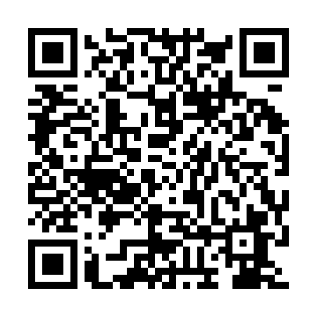
Prayer times for Srebrny Borek, Poland
Wed 1 May 2024 - Fri 31 May 2024
High Latitude Method: Angle Based Rule
Prayer Calculation Method: Muslim World League
Asar Calculation Method: Hanafi

Date | Day | Fajr | Sunrise | Dhuhr | Asr | Maghrib | Isha
1 | Wed | 2:17 | 4:58 | 12:28 | 5:37 | 8:00 | 10:28
2 | Thu | 2:16 | 4:56 | 12:28 | 5:38 | 8:02 | 10:32
3 | Fri | 2:15 | 4:54 | 12:28 | 5:39 | 8:03 | 10:34
4 | Sat | 2:14 | 4:52 | 12:28 | 5:40 | 8:05 | 10:34
5 | Sun | 2:13 | 4:50 | 12:28 | 5:41 | 8:07 | 10:35
6 | Mon | 2:12 | 4:48 | 12:28 | 5:42 | 8:08 | 10:36
7 | Tue | 2:12 | 4:46 | 12:28 | 5:43 | 8:10 | 10:36
8 | Wed | 2:11 | 4:45 | 12:28 | 5:44 | 8:12 | 10:37
9 | Thu | 2:10 | 4:43 | 12:28 | 5:45 | 8:13 | 10:38
10 | Fri | 2:09 | 4:41 | 12:28 | 5:46 | 8:15 | 10:38
11 | Sat | 2:09 | 4:39 | 12:28 | 5:47 | 8:17 | 10:39
12 | Sun | 2:08 | 4:38 | 12:28 | 5:48 | 8:18 | 10:40
13 | Mon | 2:07 | 4:36 | 12:28 | 5:49 | 8:20 | 10:41
14 | Tue | 2:07 | 4:34 | 12:28 | 5:50 | 8:22 | 10:41
15 | Wed | 2:06 | 4:33 | 12:28 | 5:51 | 8:23 | 10:42
16 | Thu | 2:05 | 4:31 | 12:28 | 5:52 | 8:25 | 10:43
17 | Fri | 2:05 | 4:30 | 12:28 | 5:53 | 8:26 | 10:43
18 | Sat | 2:04 | 4:28 | 12:28 | 5:54 | 8:28 | 10:44
19 | Sun | 2:04 | 4:27 | 12:28 | 5:55 | 8:29 | 10:45
20 | Mon | 2:03 | 4:25 | 12:28 | 5:56 | 8:31 | 10:45
21 | Tue | 2:03 | 4:24 | 12:28 | 5:57 | 8:32 | 10:46
22 | Wed | 2:02 | 4:23 | 12:28 | 5:57 | 8:34 | 10:47
23 | Thu | 2:02 | 4:21 | 12:28 | 5:58 | 8:35 | 10:47
24 | Fri | 2:01 | 4:20 | 12:28 | 5:59 | 8:37 | 10:48
25 | Sat | 2:01 | 4:19 | 12:28 | 6:00 | 8:38 | 10:49
26 | Sun | 2:00 | 4:18 | 12:28 | 6:01 | 8:40 | 10:49
27 | Mon | 2:00 | 4:17 | 12:29 | 6:01 | 8:41 | 10:50
28 | Tue | 2:00 | 4:16 | 12:29 | 6:02 | 8:42 | 10:51
29 | Wed | 1:59 | 4:15 | 12:29 | 6:03 | 8:43 | 10:51
30 | Thu | 1:59 | 4:14 | 12:29 | 6:04 | 8:45 | 10:52
31 | Fri | 1:59 | 4:13 | 12:29 | 6:04 | 8:46 | 10:52
Prayer times provided by https://www.salahtimes.com

