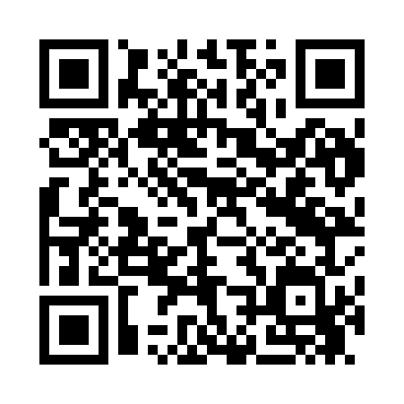

**Prayer times for Abaja, Estonia**

**Sun 1 Sep 2024 - Mon 30 Sep 2024**

**High Latitude Method: Angle Based Rule**

**Prayer Calculation Method: Muslim World League**

**Asar Calculation Method: Hanafi**

|  |  |  |  |  |  |  |  |
| --- | --- | --- | --- | --- | --- | --- | --- |
| **Date** | **Day** | **Fajr** | **Sunrise** | **Dhuhr** | **Asr** | **Maghrib** | **Isha** |
| 1 | Sun | 3:27 | 6:15 | 1:16 | 5:55 | 8:16 | 10:50 |
| 2 | Mon | 3:31 | 6:17 | 1:16 | 5:53 | 8:13 | 10:45 |
| 3 | Tue | 3:36 | 6:19 | 1:15 | 5:51 | 8:10 | 10:40 |
| 4 | Wed | 3:40 | 6:21 | 1:15 | 5:49 | 8:07 | 10:36 |
| 5 | Thu | 3:44 | 6:24 | 1:15 | 5:46 | 8:05 | 10:32 |
| 6 | Fri | 3:48 | 6:26 | 1:14 | 5:44 | 8:02 | 10:27 |
| 7 | Sat | 3:51 | 6:28 | 1:14 | 5:42 | 7:59 | 10:23 |
| 8 | Sun | 3:55 | 6:30 | 1:14 | 5:40 | 7:56 | 10:19 |
| 9 | Mon | 3:59 | 6:33 | 1:13 | 5:37 | 7:53 | 10:15 |
| 10 | Tue | 4:02 | 6:35 | 1:13 | 5:35 | 7:50 | 10:11 |
| 11 | Wed | 4:06 | 6:37 | 1:13 | 5:33 | 7:47 | 10:07 |
| 12 | Thu | 4:09 | 6:39 | 1:12 | 5:30 | 7:44 | 10:03 |
| 13 | Fri | 4:13 | 6:41 | 1:12 | 5:28 | 7:41 | 9:59 |
| 14 | Sat | 4:16 | 6:44 | 1:12 | 5:25 | 7:38 | 9:55 |
| 15 | Sun | 4:19 | 6:46 | 1:11 | 5:23 | 7:35 | 9:51 |
| 16 | Mon | 4:22 | 6:48 | 1:11 | 5:21 | 7:32 | 9:48 |
| 17 | Tue | 4:26 | 6:50 | 1:11 | 5:18 | 7:29 | 9:44 |
| 18 | Wed | 4:29 | 6:53 | 1:10 | 5:16 | 7:26 | 9:40 |
| 19 | Thu | 4:32 | 6:55 | 1:10 | 5:13 | 7:24 | 9:37 |
| 20 | Fri | 4:35 | 6:57 | 1:09 | 5:11 | 7:21 | 9:33 |
| 21 | Sat | 4:38 | 6:59 | 1:09 | 5:08 | 7:18 | 9:30 |
| 22 | Sun | 4:40 | 7:01 | 1:09 | 5:06 | 7:15 | 9:26 |
| 23 | Mon | 4:43 | 7:04 | 1:08 | 5:04 | 7:12 | 9:23 |
| 24 | Tue | 4:46 | 7:06 | 1:08 | 5:01 | 7:09 | 9:19 |
| 25 | Wed | 4:49 | 7:08 | 1:08 | 4:59 | 7:06 | 9:16 |
| 26 | Thu | 4:52 | 7:10 | 1:07 | 4:56 | 7:03 | 9:13 |
| 27 | Fri | 4:54 | 7:13 | 1:07 | 4:54 | 7:00 | 9:09 |
| 28 | Sat | 4:57 | 7:15 | 1:07 | 4:51 | 6:57 | 9:06 |
| 29 | Sun | 5:00 | 7:17 | 1:06 | 4:49 | 6:54 | 9:03 |
| 30 | Mon | 5:02 | 7:19 | 1:06 | 4:46 | 6:51 | 8:59 |

**Prayer times provided by https://www.salahtimes.com**