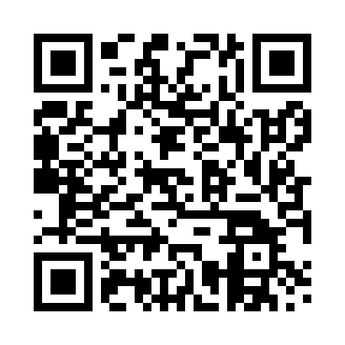

**Prayer times for Abbetved, Denmark**

**Sun 1 Sep 2024 - Mon 30 Sep 2024**

**High Latitude Method: Angle Based Rule**

**Prayer Calculation Method: Muslim World League**

**Asar Calculation Method: Hanafi**

|  |  |  |  |  |  |  |  |
| --- | --- | --- | --- | --- | --- | --- | --- |
| **Date** | **Day** | **Fajr** | **Sunrise** | **Dhuhr** | **Asr** | **Maghrib** | **Isha** |
| 1 | Sun | 3:54 | 6:18 | 1:12 | 5:52 | 8:05 | 10:18 |
| 2 | Mon | 3:57 | 6:20 | 1:12 | 5:50 | 8:03 | 10:15 |
| 3 | Tue | 4:00 | 6:22 | 1:12 | 5:48 | 8:00 | 10:11 |
| 4 | Wed | 4:03 | 6:24 | 1:11 | 5:46 | 7:57 | 10:08 |
| 5 | Thu | 4:06 | 6:26 | 1:11 | 5:44 | 7:55 | 10:04 |
| 6 | Fri | 4:09 | 6:28 | 1:11 | 5:42 | 7:52 | 10:01 |
| 7 | Sat | 4:12 | 6:30 | 1:10 | 5:39 | 7:50 | 9:57 |
| 8 | Sun | 4:15 | 6:32 | 1:10 | 5:37 | 7:47 | 9:54 |
| 9 | Mon | 4:18 | 6:33 | 1:10 | 5:35 | 7:44 | 9:50 |
| 10 | Tue | 4:21 | 6:35 | 1:09 | 5:33 | 7:42 | 9:47 |
| 11 | Wed | 4:23 | 6:37 | 1:09 | 5:31 | 7:39 | 9:44 |
| 12 | Thu | 4:26 | 6:39 | 1:08 | 5:29 | 7:37 | 9:40 |
| 13 | Fri | 4:29 | 6:41 | 1:08 | 5:27 | 7:34 | 9:37 |
| 14 | Sat | 4:31 | 6:43 | 1:08 | 5:25 | 7:31 | 9:34 |
| 15 | Sun | 4:34 | 6:45 | 1:07 | 5:23 | 7:29 | 9:31 |
| 16 | Mon | 4:37 | 6:47 | 1:07 | 5:20 | 7:26 | 9:28 |
| 17 | Tue | 4:39 | 6:49 | 1:07 | 5:18 | 7:23 | 9:24 |
| 18 | Wed | 4:42 | 6:51 | 1:06 | 5:16 | 7:21 | 9:21 |
| 19 | Thu | 4:44 | 6:53 | 1:06 | 5:14 | 7:18 | 9:18 |
| 20 | Fri | 4:46 | 6:55 | 1:06 | 5:12 | 7:16 | 9:15 |
| 21 | Sat | 4:49 | 6:56 | 1:05 | 5:09 | 7:13 | 9:12 |
| 22 | Sun | 4:51 | 6:58 | 1:05 | 5:07 | 7:10 | 9:09 |
| 23 | Mon | 4:54 | 7:00 | 1:05 | 5:05 | 7:08 | 9:06 |
| 24 | Tue | 4:56 | 7:02 | 1:04 | 5:03 | 7:05 | 9:03 |
| 25 | Wed | 4:58 | 7:04 | 1:04 | 5:00 | 7:02 | 9:00 |
| 26 | Thu | 5:01 | 7:06 | 1:04 | 4:58 | 7:00 | 8:57 |
| 27 | Fri | 5:03 | 7:08 | 1:03 | 4:56 | 6:57 | 8:54 |
| 28 | Sat | 5:05 | 7:10 | 1:03 | 4:54 | 6:55 | 8:51 |
| 29 | Sun | 5:07 | 7:12 | 1:02 | 4:51 | 6:52 | 8:49 |
| 30 | Mon | 5:10 | 7:14 | 1:02 | 4:49 | 6:49 | 8:46 |

**Prayer times provided by https://www.salahtimes.com**