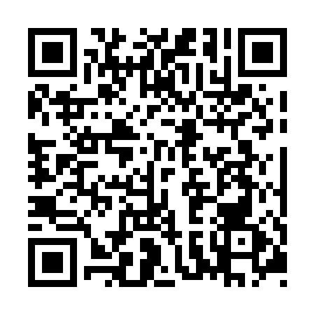
Prayer times for Sitiit Ivigaarittuit, Quebec, Canada
Mon 1 Jul 2024 - Wed 31 Jul 2024
High Latitude Method: Angle Based Rule
Prayer Calculation Method: Islamic Society of North America
Asar Calculation Method: Hanafi

Date | Day | Fajr | Sunrise | Dhuhr | Asr | Maghrib | Isha
1 | Mon | 2:37 | 4:03 | 1:11 | 7:05 | 10:18 | 11:44
2 | Tue | 2:37 | 4:04 | 1:11 | 7:05 | 10:17 | 11:44
3 | Wed | 2:38 | 4:05 | 1:11 | 7:05 | 10:16 | 11:44
4 | Thu | 2:39 | 4:06 | 1:11 | 7:05 | 10:15 | 11:43
5 | Fri | 2:39 | 4:08 | 1:11 | 7:04 | 10:15 | 11:43
6 | Sat | 2:40 | 4:09 | 1:12 | 7:04 | 10:14 | 11:42
7 | Sun | 2:41 | 4:10 | 1:12 | 7:04 | 10:12 | 11:42
8 | Mon | 2:42 | 4:12 | 1:12 | 7:03 | 10:11 | 11:41
9 | Tue | 2:42 | 4:13 | 1:12 | 7:03 | 10:10 | 11:41
10 | Wed | 2:43 | 4:15 | 1:12 | 7:02 | 10:09 | 11:40
11 | Thu | 2:44 | 4:16 | 1:12 | 7:01 | 10:07 | 11:40
12 | Fri | 2:45 | 4:18 | 1:12 | 7:01 | 10:06 | 11:39
13 | Sat | 2:46 | 4:20 | 1:13 | 7:00 | 10:05 | 11:38
14 | Sun | 2:47 | 4:21 | 1:13 | 7:00 | 10:03 | 11:38
15 | Mon | 2:48 | 4:23 | 1:13 | 6:59 | 10:01 | 11:37
16 | Tue | 2:49 | 4:25 | 1:13 | 6:58 | 10:00 | 11:36
17 | Wed | 2:50 | 4:27 | 1:13 | 6:57 | 9:58 | 11:35
18 | Thu | 2:51 | 4:29 | 1:13 | 6:56 | 9:56 | 11:34
19 | Fri | 2:52 | 4:30 | 1:13 | 6:56 | 9:55 | 11:34
20 | Sat | 2:53 | 4:32 | 1:13 | 6:55 | 9:53 | 11:33
21 | Sun | 2:54 | 4:34 | 1:13 | 6:54 | 9:51 | 11:32
22 | Mon | 2:55 | 4:36 | 1:13 | 6:53 | 9:49 | 11:31
23 | Tue | 2:56 | 4:38 | 1:13 | 6:52 | 9:47 | 11:30
24 | Wed | 2:57 | 4:40 | 1:13 | 6:51 | 9:45 | 11:29
25 | Thu | 2:58 | 4:42 | 1:13 | 6:50 | 9:43 | 11:28
26 | Fri | 2:59 | 4:45 | 1:13 | 6:48 | 9:41 | 11:27
27 | Sat | 3:00 | 4:47 | 1:13 | 6:47 | 9:39 | 11:26
28 | Sun | 3:01 | 4:49 | 1:13 | 6:46 | 9:36 | 11:25
29 | Mon | 3:02 | 4:51 | 1:13 | 6:45 | 9:34 | 11:23
30 | Tue | 3:03 | 4:53 | 1:13 | 6:44 | 9:32 | 11:22
31 | Wed | 3:04 | 4:55 | 1:13 | 6:42 | 9:30 | 11:21
Prayer times provided by https://www.salahtimes.com

