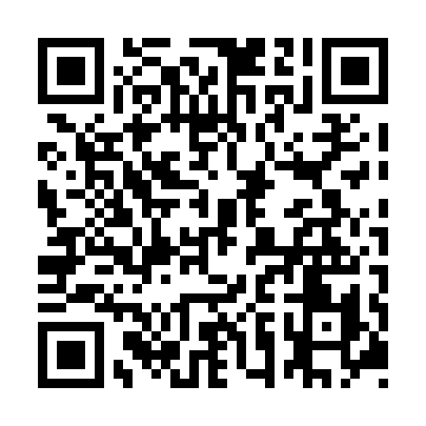
Prayer times for Churchill Park, Newfoundland and Labrador, Canada
Mon 1 Apr 2024 - Tue 30 Apr 2024
High Latitude Method: Angle Based Rule
Prayer Calculation Method: Islamic Society of North America
Asar Calculation Method: Hanafi

Date | Day | Fajr | Sunrise | Dhuhr | Asr | Maghrib | Isha
1 | Mon | 5:11 | 6:39 | 1:05 | 5:33 | 7:31 | 8:59
2 | Tue | 5:09 | 6:37 | 1:04 | 5:34 | 7:33 | 9:01
3 | Wed | 5:06 | 6:35 | 1:04 | 5:35 | 7:34 | 9:03
4 | Thu | 5:04 | 6:33 | 1:04 | 5:36 | 7:36 | 9:05
5 | Fri | 5:02 | 6:31 | 1:03 | 5:37 | 7:37 | 9:06
6 | Sat | 4:59 | 6:29 | 1:03 | 5:38 | 7:38 | 9:08
7 | Sun | 4:57 | 6:27 | 1:03 | 5:39 | 7:40 | 9:10
8 | Mon | 4:55 | 6:25 | 1:03 | 5:40 | 7:41 | 9:12
9 | Tue | 4:52 | 6:23 | 1:02 | 5:41 | 7:43 | 9:13
10 | Wed | 4:50 | 6:21 | 1:02 | 5:42 | 7:44 | 9:15
11 | Thu | 4:48 | 6:19 | 1:02 | 5:43 | 7:46 | 9:17
12 | Fri | 4:45 | 6:17 | 1:02 | 5:44 | 7:47 | 9:19
13 | Sat | 4:43 | 6:15 | 1:01 | 5:45 | 7:48 | 9:21
14 | Sun | 4:41 | 6:13 | 1:01 | 5:46 | 7:50 | 9:22
15 | Mon | 4:38 | 6:11 | 1:01 | 5:47 | 7:51 | 9:24
16 | Tue | 4:36 | 6:09 | 1:01 | 5:48 | 7:53 | 9:26
17 | Wed | 4:34 | 6:07 | 1:00 | 5:49 | 7:54 | 9:28
18 | Thu | 4:31 | 6:06 | 1:00 | 5:50 | 7:55 | 9:30
19 | Fri | 4:29 | 6:04 | 1:00 | 5:51 | 7:57 | 9:32
20 | Sat | 4:27 | 6:02 | 1:00 | 5:51 | 7:58 | 9:34
21 | Sun | 4:24 | 6:00 | 12:59 | 5:52 | 8:00 | 9:36
22 | Mon | 4:22 | 5:58 | 12:59 | 5:53 | 8:01 | 9:38
23 | Tue | 4:20 | 5:57 | 12:59 | 5:54 | 8:02 | 9:40
24 | Wed | 4:17 | 5:55 | 12:59 | 5:55 | 8:04 | 9:42
25 | Thu | 4:15 | 5:53 | 12:59 | 5:56 | 8:05 | 9:44
26 | Fri | 4:13 | 5:51 | 12:59 | 5:57 | 8:07 | 9:46
27 | Sat | 4:11 | 5:50 | 12:58 | 5:58 | 8:08 | 9:48
28 | Sun | 4:08 | 5:48 | 12:58 | 5:58 | 8:09 | 9:50
29 | Mon | 4:06 | 5:46 | 12:58 | 5:59 | 8:11 | 9:52
30 | Tue | 4:04 | 5:45 | 12:58 | 6:00 | 8:12 | 9:54
Prayer times provided by https://www.salahtimes.com

