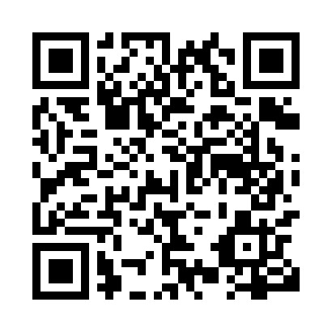

**Prayer times for Scotts Hill, Manitoba, Canada**

**Sun 1 Sep 2024 - Mon 30 Sep 2024**

**High Latitude Method: Angle Based Rule**

**Prayer Calculation Method: Islamic Society of North America**

**Asar Calculation Method: Hanafi**

|  |  |  |  |  |  |  |  |
| --- | --- | --- | --- | --- | --- | --- | --- |
| **Date** | **Day** | **Fajr** | **Sunrise** | **Dhuhr** | **Asr** | **Maghrib** | **Isha** |
| 1 | Sun | 5:03 | 6:40 | 1:23 | 6:02 | 8:06 | 9:42 |
| 2 | Mon | 5:05 | 6:41 | 1:23 | 6:01 | 8:04 | 9:39 |
| 3 | Tue | 5:07 | 6:43 | 1:23 | 5:59 | 8:02 | 9:37 |
| 4 | Wed | 5:09 | 6:44 | 1:22 | 5:57 | 8:00 | 9:34 |
| 5 | Thu | 5:11 | 6:46 | 1:22 | 5:55 | 7:58 | 9:32 |
| 6 | Fri | 5:13 | 6:47 | 1:22 | 5:54 | 7:55 | 9:29 |
| 7 | Sat | 5:15 | 6:49 | 1:21 | 5:52 | 7:53 | 9:27 |
| 8 | Sun | 5:17 | 6:50 | 1:21 | 5:50 | 7:51 | 9:24 |
| 9 | Mon | 5:18 | 6:52 | 1:21 | 5:49 | 7:49 | 9:22 |
| 10 | Tue | 5:20 | 6:53 | 1:20 | 5:47 | 7:47 | 9:19 |
| 11 | Wed | 5:22 | 6:54 | 1:20 | 5:45 | 7:44 | 9:17 |
| 12 | Thu | 5:24 | 6:56 | 1:20 | 5:43 | 7:42 | 9:14 |
| 13 | Fri | 5:26 | 6:57 | 1:19 | 5:41 | 7:40 | 9:12 |
| 14 | Sat | 5:27 | 6:59 | 1:19 | 5:40 | 7:38 | 9:09 |
| 15 | Sun | 5:29 | 7:00 | 1:18 | 5:38 | 7:36 | 9:07 |
| 16 | Mon | 5:31 | 7:02 | 1:18 | 5:36 | 7:33 | 9:04 |
| 17 | Tue | 5:33 | 7:03 | 1:18 | 5:34 | 7:31 | 9:02 |
| 18 | Wed | 5:34 | 7:05 | 1:17 | 5:32 | 7:29 | 8:59 |
| 19 | Thu | 5:36 | 7:06 | 1:17 | 5:30 | 7:27 | 8:57 |
| 20 | Fri | 5:38 | 7:08 | 1:17 | 5:28 | 7:25 | 8:55 |
| 21 | Sat | 5:39 | 7:09 | 1:16 | 5:27 | 7:22 | 8:52 |
| 22 | Sun | 5:41 | 7:11 | 1:16 | 5:25 | 7:20 | 8:50 |
| 23 | Mon | 5:43 | 7:12 | 1:16 | 5:23 | 7:18 | 8:47 |
| 24 | Tue | 5:44 | 7:14 | 1:15 | 5:21 | 7:16 | 8:45 |
| 25 | Wed | 5:46 | 7:15 | 1:15 | 5:19 | 7:14 | 8:43 |
| 26 | Thu | 5:48 | 7:17 | 1:15 | 5:17 | 7:11 | 8:40 |
| 27 | Fri | 5:49 | 7:18 | 1:14 | 5:15 | 7:09 | 8:38 |
| 28 | Sat | 5:51 | 7:20 | 1:14 | 5:13 | 7:07 | 8:36 |
| 29 | Sun | 5:53 | 7:21 | 1:14 | 5:11 | 7:05 | 8:34 |
| 30 | Mon | 5:54 | 7:23 | 1:13 | 5:10 | 7:03 | 8:31 |

**Prayer times provided by https://www.salahtimes.com**