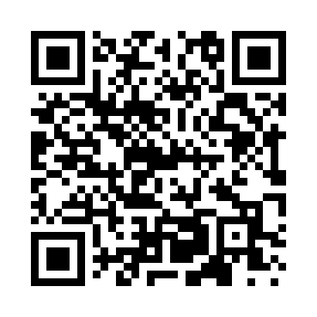
Prayer times for Beck Place, Wyoming, USA
Wed 1 May 2024 - Fri 31 May 2024
High Latitude Method: Angle Based Rule
Prayer Calculation Method: Islamic Society of North America
Asar Calculation Method: Shafi

Date | Day | Fajr | Sunrise | Dhuhr | Asr | Maghrib | Isha
1 | Wed | 4:29 | 5:59 | 1:04 | 4:58 | 8:09 | 9:39
2 | Thu | 4:28 | 5:58 | 1:04 | 4:59 | 8:10 | 9:41
3 | Fri | 4:26 | 5:57 | 1:04 | 4:59 | 8:11 | 9:42
4 | Sat | 4:24 | 5:55 | 1:04 | 4:59 | 8:12 | 9:44
5 | Sun | 4:22 | 5:54 | 1:03 | 5:00 | 8:13 | 9:46
6 | Mon | 4:21 | 5:53 | 1:03 | 5:00 | 8:15 | 9:47
7 | Tue | 4:19 | 5:52 | 1:03 | 5:00 | 8:16 | 9:49
8 | Wed | 4:17 | 5:50 | 1:03 | 5:01 | 8:17 | 9:50
9 | Thu | 4:15 | 5:49 | 1:03 | 5:01 | 8:18 | 9:52
10 | Fri | 4:14 | 5:48 | 1:03 | 5:01 | 8:19 | 9:54
11 | Sat | 4:12 | 5:47 | 1:03 | 5:02 | 8:20 | 9:55
12 | Sun | 4:11 | 5:46 | 1:03 | 5:02 | 8:21 | 9:57
13 | Mon | 4:09 | 5:45 | 1:03 | 5:02 | 8:22 | 9:58
14 | Tue | 4:07 | 5:44 | 1:03 | 5:03 | 8:23 | 10:00
15 | Wed | 4:06 | 5:43 | 1:03 | 5:03 | 8:24 | 10:01
16 | Thu | 4:04 | 5:42 | 1:03 | 5:04 | 8:25 | 10:03
17 | Fri | 4:03 | 5:41 | 1:03 | 5:04 | 8:27 | 10:04
18 | Sat | 4:02 | 5:40 | 1:03 | 5:04 | 8:28 | 10:06
19 | Sun | 4:00 | 5:39 | 1:03 | 5:05 | 8:29 | 10:07
20 | Mon | 3:59 | 5:38 | 1:03 | 5:05 | 8:30 | 10:09
21 | Tue | 3:57 | 5:37 | 1:04 | 5:05 | 8:31 | 10:10
22 | Wed | 3:56 | 5:36 | 1:04 | 5:06 | 8:32 | 10:12
23 | Thu | 3:55 | 5:35 | 1:04 | 5:06 | 8:32 | 10:13
24 | Fri | 3:54 | 5:35 | 1:04 | 5:06 | 8:33 | 10:15
25 | Sat | 3:52 | 5:34 | 1:04 | 5:07 | 8:34 | 10:16
26 | Sun | 3:51 | 5:33 | 1:04 | 5:07 | 8:35 | 10:17
27 | Mon | 3:50 | 5:32 | 1:04 | 5:07 | 8:36 | 10:19
28 | Tue | 3:49 | 5:32 | 1:04 | 5:07 | 8:37 | 10:20
29 | Wed | 3:48 | 5:31 | 1:04 | 5:08 | 8:38 | 10:21
30 | Thu | 3:47 | 5:31 | 1:05 | 5:08 | 8:39 | 10:23
31 | Fri | 3:46 | 5:30 | 1:05 | 5:08 | 8:40 | 10:24
Prayer times provided by https://www.salahtimes.com

