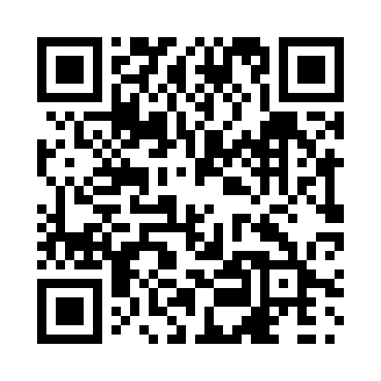

**Prayer times for Fox Lake, Alberta, Canada**

**Sun 1 Sep 2024 - Mon 30 Sep 2024**

**High Latitude Method: Angle Based Rule**

**Prayer Calculation Method: Islamic Society of North America**

**Asar Calculation Method: Hanafi**

|  |  |  |  |  |  |  |  |
| --- | --- | --- | --- | --- | --- | --- | --- |
| **Date** | **Day** | **Fajr** | **Sunrise** | **Dhuhr** | **Asr** | **Maghrib** | **Isha** |
| 1 | Sun | 4:31 | 6:39 | 1:38 | 6:16 | 8:36 | 10:43 |
| 2 | Mon | 4:34 | 6:41 | 1:38 | 6:14 | 8:33 | 10:39 |
| 3 | Tue | 4:38 | 6:43 | 1:37 | 6:12 | 8:30 | 10:35 |
| 4 | Wed | 4:41 | 6:45 | 1:37 | 6:10 | 8:27 | 10:31 |
| 5 | Thu | 4:44 | 6:47 | 1:37 | 6:08 | 8:25 | 10:27 |
| 6 | Fri | 4:47 | 6:50 | 1:36 | 6:05 | 8:22 | 10:23 |
| 7 | Sat | 4:50 | 6:52 | 1:36 | 6:03 | 8:19 | 10:20 |
| 8 | Sun | 4:53 | 6:54 | 1:36 | 6:01 | 8:16 | 10:16 |
| 9 | Mon | 4:56 | 6:56 | 1:35 | 5:59 | 8:13 | 10:12 |
| 10 | Tue | 4:59 | 6:58 | 1:35 | 5:56 | 8:10 | 10:09 |
| 11 | Wed | 5:02 | 7:00 | 1:34 | 5:54 | 8:07 | 10:05 |
| 12 | Thu | 5:05 | 7:03 | 1:34 | 5:52 | 8:04 | 10:02 |
| 13 | Fri | 5:08 | 7:05 | 1:34 | 5:49 | 8:02 | 9:58 |
| 14 | Sat | 5:11 | 7:07 | 1:33 | 5:47 | 7:59 | 9:55 |
| 15 | Sun | 5:13 | 7:09 | 1:33 | 5:45 | 7:56 | 9:51 |
| 16 | Mon | 5:16 | 7:11 | 1:33 | 5:42 | 7:53 | 9:48 |
| 17 | Tue | 5:19 | 7:13 | 1:32 | 5:40 | 7:50 | 9:44 |
| 18 | Wed | 5:22 | 7:16 | 1:32 | 5:37 | 7:47 | 9:41 |
| 19 | Thu | 5:24 | 7:18 | 1:32 | 5:35 | 7:44 | 9:37 |
| 20 | Fri | 5:27 | 7:20 | 1:31 | 5:33 | 7:41 | 9:34 |
| 21 | Sat | 5:29 | 7:22 | 1:31 | 5:30 | 7:38 | 9:31 |
| 22 | Sun | 5:32 | 7:24 | 1:31 | 5:28 | 7:35 | 9:28 |
| 23 | Mon | 5:35 | 7:27 | 1:30 | 5:25 | 7:33 | 9:24 |
| 24 | Tue | 5:37 | 7:29 | 1:30 | 5:23 | 7:30 | 9:21 |
| 25 | Wed | 5:40 | 7:31 | 1:30 | 5:20 | 7:27 | 9:18 |
| 26 | Thu | 5:42 | 7:33 | 1:29 | 5:18 | 7:24 | 9:15 |
| 27 | Fri | 5:45 | 7:35 | 1:29 | 5:15 | 7:21 | 9:12 |
| 28 | Sat | 5:47 | 7:38 | 1:29 | 5:13 | 7:18 | 9:09 |
| 29 | Sun | 5:49 | 7:40 | 1:28 | 5:11 | 7:15 | 9:05 |
| 30 | Mon | 5:52 | 7:42 | 1:28 | 5:08 | 7:12 | 9:02 |

**Prayer times provided by https://www.salahtimes.com**