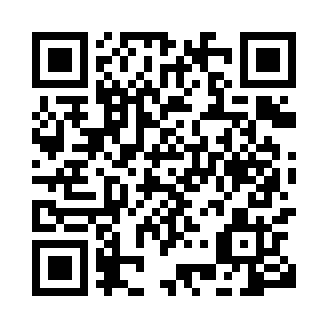
Prayer times for Bele Salo, Cameroon
Wed 1 May 2024 - Fri 31 May 2024
High Latitude Method: None
Prayer Calculation Method: Muslim World League
Asar Calculation Method: Shafi

Date | Day | Fajr | Sunrise | Dhuhr | Asr | Maghrib | Isha
1 | Wed | 4:44 | 5:56 | 12:06 | 3:24 | 6:16 | 7:24
2 | Thu | 4:44 | 5:56 | 12:06 | 3:24 | 6:16 | 7:24
3 | Fri | 4:43 | 5:56 | 12:06 | 3:24 | 6:16 | 7:24
4 | Sat | 4:43 | 5:55 | 12:06 | 3:25 | 6:16 | 7:24
5 | Sun | 4:43 | 5:55 | 12:06 | 3:25 | 6:16 | 7:24
6 | Mon | 4:42 | 5:55 | 12:05 | 3:25 | 6:16 | 7:24
7 | Tue | 4:42 | 5:55 | 12:05 | 3:26 | 6:16 | 7:25
8 | Wed | 4:42 | 5:55 | 12:05 | 3:26 | 6:16 | 7:25
9 | Thu | 4:41 | 5:54 | 12:05 | 3:26 | 6:16 | 7:25
10 | Fri | 4:41 | 5:54 | 12:05 | 3:26 | 6:16 | 7:25
11 | Sat | 4:41 | 5:54 | 12:05 | 3:27 | 6:16 | 7:25
12 | Sun | 4:41 | 5:54 | 12:05 | 3:27 | 6:17 | 7:26
13 | Mon | 4:40 | 5:54 | 12:05 | 3:27 | 6:17 | 7:26
14 | Tue | 4:40 | 5:54 | 12:05 | 3:28 | 6:17 | 7:26
15 | Wed | 4:40 | 5:54 | 12:05 | 3:28 | 6:17 | 7:26
16 | Thu | 4:40 | 5:54 | 12:05 | 3:28 | 6:17 | 7:27
17 | Fri | 4:40 | 5:53 | 12:05 | 3:28 | 6:17 | 7:27
18 | Sat | 4:39 | 5:53 | 12:05 | 3:29 | 6:17 | 7:27
19 | Sun | 4:39 | 5:53 | 12:05 | 3:29 | 6:18 | 7:27
20 | Mon | 4:39 | 5:53 | 12:05 | 3:29 | 6:18 | 7:28
21 | Tue | 4:39 | 5:53 | 12:06 | 3:30 | 6:18 | 7:28
22 | Wed | 4:39 | 5:53 | 12:06 | 3:30 | 6:18 | 7:28
23 | Thu | 4:39 | 5:53 | 12:06 | 3:30 | 6:18 | 7:28
24 | Fri | 4:39 | 5:53 | 12:06 | 3:30 | 6:18 | 7:29
25 | Sat | 4:38 | 5:53 | 12:06 | 3:31 | 6:19 | 7:29
26 | Sun | 4:38 | 5:53 | 12:06 | 3:31 | 6:19 | 7:29
27 | Mon | 4:38 | 5:53 | 12:06 | 3:31 | 6:19 | 7:30
28 | Tue | 4:38 | 5:53 | 12:06 | 3:32 | 6:19 | 7:30
29 | Wed | 4:38 | 5:53 | 12:06 | 3:32 | 6:19 | 7:30
30 | Thu | 4:38 | 5:53 | 12:06 | 3:32 | 6:20 | 7:30
31 | Fri | 4:38 | 5:54 | 12:07 | 3:33 | 6:20 | 7:31
Prayer times provided by https://www.salahtimes.com

