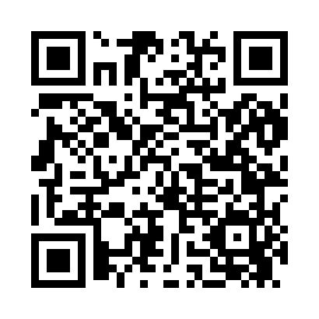
Prayer times for Algoso, California, USA
Sat 1 Jun 2024 - Sun 30 Jun 2024
High Latitude Method: Angle Based Rule
Prayer Calculation Method: Islamic Society of North America
Asar Calculation Method: Shafi

Date | Day | Fajr | Sunrise | Dhuhr | Asr | Maghrib | Isha
1 | Sat | 4:17 | 5:42 | 12:54 | 4:42 | 8:06 | 9:31
2 | Sun | 4:16 | 5:42 | 12:54 | 4:42 | 8:06 | 9:32
3 | Mon | 4:16 | 5:41 | 12:54 | 4:42 | 8:07 | 9:32
4 | Tue | 4:16 | 5:41 | 12:54 | 4:42 | 8:08 | 9:33
5 | Wed | 4:15 | 5:41 | 12:54 | 4:43 | 8:08 | 9:34
6 | Thu | 4:15 | 5:41 | 12:55 | 4:43 | 8:09 | 9:34
7 | Fri | 4:15 | 5:41 | 12:55 | 4:43 | 8:09 | 9:35
8 | Sat | 4:14 | 5:40 | 12:55 | 4:43 | 8:10 | 9:36
9 | Sun | 4:14 | 5:40 | 12:55 | 4:43 | 8:10 | 9:36
10 | Mon | 4:14 | 5:40 | 12:55 | 4:44 | 8:11 | 9:37
11 | Tue | 4:14 | 5:40 | 12:56 | 4:44 | 8:11 | 9:37
12 | Wed | 4:14 | 5:40 | 12:56 | 4:44 | 8:11 | 9:38
13 | Thu | 4:14 | 5:40 | 12:56 | 4:44 | 8:12 | 9:38
14 | Fri | 4:14 | 5:40 | 12:56 | 4:45 | 8:12 | 9:39
15 | Sat | 4:14 | 5:40 | 12:56 | 4:45 | 8:13 | 9:39
16 | Sun | 4:14 | 5:40 | 12:57 | 4:45 | 8:13 | 9:40
17 | Mon | 4:14 | 5:41 | 12:57 | 4:45 | 8:13 | 9:40
18 | Tue | 4:14 | 5:41 | 12:57 | 4:45 | 8:13 | 9:40
19 | Wed | 4:14 | 5:41 | 12:57 | 4:46 | 8:14 | 9:41
20 | Thu | 4:14 | 5:41 | 12:57 | 4:46 | 8:14 | 9:41
21 | Fri | 4:14 | 5:41 | 12:58 | 4:46 | 8:14 | 9:41
22 | Sat | 4:15 | 5:42 | 12:58 | 4:46 | 8:14 | 9:41
23 | Sun | 4:15 | 5:42 | 12:58 | 4:47 | 8:14 | 9:41
24 | Mon | 4:15 | 5:42 | 12:58 | 4:47 | 8:15 | 9:41
25 | Tue | 4:16 | 5:42 | 12:59 | 4:47 | 8:15 | 9:41
26 | Wed | 4:16 | 5:43 | 12:59 | 4:47 | 8:15 | 9:41
27 | Thu | 4:16 | 5:43 | 12:59 | 4:47 | 8:15 | 9:41
28 | Fri | 4:17 | 5:44 | 12:59 | 4:48 | 8:15 | 9:41
29 | Sat | 4:17 | 5:44 | 12:59 | 4:48 | 8:15 | 9:41
30 | Sun | 4:18 | 5:44 | 1:00 | 4:48 | 8:15 | 9:41
Prayer times provided by https://www.salahtimes.com

