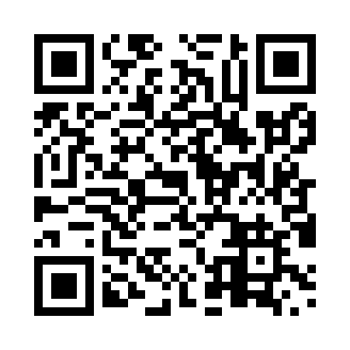
Prayer times for Beaver Point, British Columbia, Canada
Wed 1 May 2024 - Fri 31 May 2024
High Latitude Method: Angle Based Rule
Prayer Calculation Method: Islamic Society of North America
Asar Calculation Method: Hanafi

Date | Day | Fajr | Sunrise | Dhuhr | Asr | Maghrib | Isha
1 | Wed | 4:06 | 5:52 | 1:11 | 6:15 | 8:30 | 10:16
2 | Thu | 4:04 | 5:50 | 1:10 | 6:16 | 8:31 | 10:18
3 | Fri | 4:02 | 5:49 | 1:10 | 6:17 | 8:33 | 10:20
4 | Sat | 3:59 | 5:47 | 1:10 | 6:18 | 8:34 | 10:23
5 | Sun | 3:57 | 5:46 | 1:10 | 6:19 | 8:36 | 10:25
6 | Mon | 3:54 | 5:44 | 1:10 | 6:19 | 8:37 | 10:27
7 | Tue | 3:52 | 5:42 | 1:10 | 6:20 | 8:38 | 10:29
8 | Wed | 3:50 | 5:41 | 1:10 | 6:21 | 8:40 | 10:32
9 | Thu | 3:47 | 5:39 | 1:10 | 6:22 | 8:41 | 10:34
10 | Fri | 3:45 | 5:38 | 1:10 | 6:23 | 8:43 | 10:36
11 | Sat | 3:43 | 5:37 | 1:10 | 6:24 | 8:44 | 10:38
12 | Sun | 3:40 | 5:35 | 1:10 | 6:24 | 8:45 | 10:41
13 | Mon | 3:38 | 5:34 | 1:10 | 6:25 | 8:47 | 10:43
14 | Tue | 3:36 | 5:32 | 1:10 | 6:26 | 8:48 | 10:45
15 | Wed | 3:34 | 5:31 | 1:10 | 6:27 | 8:49 | 10:47
16 | Thu | 3:31 | 5:30 | 1:10 | 6:28 | 8:51 | 10:50
17 | Fri | 3:29 | 5:29 | 1:10 | 6:28 | 8:52 | 10:52
18 | Sat | 3:27 | 5:27 | 1:10 | 6:29 | 8:53 | 10:54
19 | Sun | 3:25 | 5:26 | 1:10 | 6:30 | 8:55 | 10:56
20 | Mon | 3:23 | 5:25 | 1:10 | 6:31 | 8:56 | 10:59
21 | Tue | 3:21 | 5:24 | 1:10 | 6:31 | 8:57 | 11:01
22 | Wed | 3:19 | 5:23 | 1:10 | 6:32 | 8:58 | 11:03
23 | Thu | 3:17 | 5:22 | 1:10 | 6:33 | 8:59 | 11:05
24 | Fri | 3:16 | 5:21 | 1:10 | 6:34 | 9:01 | 11:06
25 | Sat | 3:15 | 5:20 | 1:11 | 6:34 | 9:02 | 11:06
26 | Sun | 3:15 | 5:19 | 1:11 | 6:35 | 9:03 | 11:07
27 | Mon | 3:15 | 5:18 | 1:11 | 6:36 | 9:04 | 11:07
28 | Tue | 3:14 | 5:17 | 1:11 | 6:36 | 9:05 | 11:08
29 | Wed | 3:14 | 5:17 | 1:11 | 6:37 | 9:06 | 11:09
30 | Thu | 3:14 | 5:16 | 1:11 | 6:37 | 9:07 | 11:09
31 | Fri | 3:13 | 5:15 | 1:11 | 6:38 | 9:08 | 11:10
Prayer times provided by https://www.salahtimes.com

