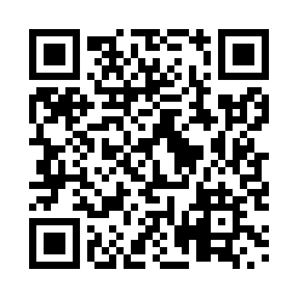
Prayer times for The Motion, Newfoundland and Labrador, Canada
Mon 1 Apr 2024 - Tue 30 Apr 2024
High Latitude Method: Angle Based Rule
Prayer Calculation Method: Islamic Society of North America
Asar Calculation Method: Hanafi

Date | Day | Fajr | Sunrise | Dhuhr | Asr | Maghrib | Isha
1 | Mon | 5:13 | 6:41 | 1:07 | 5:36 | 7:34 | 9:02
2 | Tue | 5:11 | 6:39 | 1:07 | 5:37 | 7:35 | 9:03
3 | Wed | 5:09 | 6:37 | 1:06 | 5:38 | 7:37 | 9:05
4 | Thu | 5:06 | 6:35 | 1:06 | 5:39 | 7:38 | 9:07
5 | Fri | 5:04 | 6:33 | 1:06 | 5:40 | 7:39 | 9:08
6 | Sat | 5:02 | 6:31 | 1:05 | 5:41 | 7:41 | 9:10
7 | Sun | 4:59 | 6:29 | 1:05 | 5:42 | 7:42 | 9:12
8 | Mon | 4:57 | 6:27 | 1:05 | 5:43 | 7:44 | 9:14
9 | Tue | 4:55 | 6:25 | 1:05 | 5:44 | 7:45 | 9:16
10 | Wed | 4:52 | 6:23 | 1:04 | 5:44 | 7:46 | 9:17
11 | Thu | 4:50 | 6:21 | 1:04 | 5:45 | 7:48 | 9:19
12 | Fri | 4:48 | 6:19 | 1:04 | 5:46 | 7:49 | 9:21
13 | Sat | 4:46 | 6:17 | 1:04 | 5:47 | 7:51 | 9:23
14 | Sun | 4:43 | 6:15 | 1:03 | 5:48 | 7:52 | 9:25
15 | Mon | 4:41 | 6:14 | 1:03 | 5:49 | 7:53 | 9:26
16 | Tue | 4:39 | 6:12 | 1:03 | 5:50 | 7:55 | 9:28
17 | Wed | 4:36 | 6:10 | 1:03 | 5:51 | 7:56 | 9:30
18 | Thu | 4:34 | 6:08 | 1:02 | 5:52 | 7:58 | 9:32
19 | Fri | 4:32 | 6:06 | 1:02 | 5:53 | 7:59 | 9:34
20 | Sat | 4:29 | 6:04 | 1:02 | 5:54 | 8:00 | 9:36
21 | Sun | 4:27 | 6:02 | 1:02 | 5:55 | 8:02 | 9:38
22 | Mon | 4:25 | 6:01 | 1:02 | 5:56 | 8:03 | 9:40
23 | Tue | 4:22 | 5:59 | 1:01 | 5:56 | 8:05 | 9:42
24 | Wed | 4:20 | 5:57 | 1:01 | 5:57 | 8:06 | 9:44
25 | Thu | 4:18 | 5:55 | 1:01 | 5:58 | 8:07 | 9:46
26 | Fri | 4:15 | 5:54 | 1:01 | 5:59 | 8:09 | 9:48
27 | Sat | 4:13 | 5:52 | 1:01 | 6:00 | 8:10 | 9:50
28 | Sun | 4:11 | 5:50 | 1:01 | 6:01 | 8:12 | 9:52
29 | Mon | 4:08 | 5:49 | 1:00 | 6:02 | 8:13 | 9:54
30 | Tue | 4:06 | 5:47 | 1:00 | 6:02 | 8:14 | 9:56
Prayer times provided by https://www.salahtimes.com

