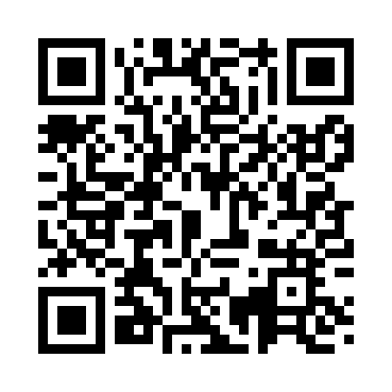
Prayer times for Soovaveski, Estonia
Wed 1 May 2024 - Fri 31 May 2024
High Latitude Method: Angle Based Rule
Prayer Calculation Method: Muslim World League
Asar Calculation Method: Hanafi

Date | Day | Fajr | Sunrise | Dhuhr | Asr | Maghrib | Isha
1 | Wed | 2:51 | 5:20 | 1:12 | 6:27 | 9:05 | 11:25
2 | Thu | 2:50 | 5:17 | 1:12 | 6:28 | 9:07 | 11:26
3 | Fri | 2:49 | 5:15 | 1:11 | 6:30 | 9:09 | 11:27
4 | Sat | 2:48 | 5:12 | 1:11 | 6:31 | 9:12 | 11:28
5 | Sun | 2:47 | 5:10 | 1:11 | 6:32 | 9:14 | 11:29
6 | Mon | 2:46 | 5:08 | 1:11 | 6:34 | 9:16 | 11:30
7 | Tue | 2:45 | 5:05 | 1:11 | 6:35 | 9:18 | 11:31
8 | Wed | 2:44 | 5:03 | 1:11 | 6:36 | 9:21 | 11:32
9 | Thu | 2:43 | 5:01 | 1:11 | 6:37 | 9:23 | 11:32
10 | Fri | 2:42 | 4:58 | 1:11 | 6:39 | 9:25 | 11:33
11 | Sat | 2:41 | 4:56 | 1:11 | 6:40 | 9:27 | 11:34
12 | Sun | 2:40 | 4:54 | 1:11 | 6:41 | 9:29 | 11:35
13 | Mon | 2:40 | 4:52 | 1:11 | 6:42 | 9:31 | 11:36
14 | Tue | 2:39 | 4:49 | 1:11 | 6:44 | 9:34 | 11:37
15 | Wed | 2:38 | 4:47 | 1:11 | 6:45 | 9:36 | 11:38
16 | Thu | 2:37 | 4:45 | 1:11 | 6:46 | 9:38 | 11:39
17 | Fri | 2:36 | 4:43 | 1:11 | 6:47 | 9:40 | 11:40
18 | Sat | 2:35 | 4:41 | 1:11 | 6:48 | 9:42 | 11:41
19 | Sun | 2:35 | 4:39 | 1:11 | 6:49 | 9:44 | 11:42
20 | Mon | 2:34 | 4:37 | 1:11 | 6:50 | 9:46 | 11:43
21 | Tue | 2:33 | 4:36 | 1:11 | 6:51 | 9:48 | 11:43
22 | Wed | 2:33 | 4:34 | 1:11 | 6:52 | 9:50 | 11:44
23 | Thu | 2:32 | 4:32 | 1:11 | 6:53 | 9:52 | 11:45
24 | Fri | 2:31 | 4:30 | 1:12 | 6:54 | 9:54 | 11:46
25 | Sat | 2:31 | 4:29 | 1:12 | 6:55 | 9:55 | 11:47
26 | Sun | 2:30 | 4:27 | 1:12 | 6:56 | 9:57 | 11:48
27 | Mon | 2:30 | 4:25 | 1:12 | 6:57 | 9:59 | 11:49
28 | Tue | 2:29 | 4:24 | 1:12 | 6:58 | 10:01 | 11:49
29 | Wed | 2:28 | 4:23 | 1:12 | 6:59 | 10:02 | 11:50
30 | Thu | 2:28 | 4:21 | 1:12 | 7:00 | 10:04 | 11:51
31 | Fri | 2:28 | 4:20 | 1:12 | 7:01 | 10:06 | 11:52
Prayer times provided by https://www.salahtimes.com

