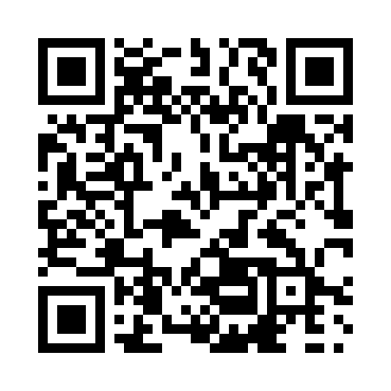

**Prayer times for Manikanis, Quebec, Canada**

**Sun 1 Sep 2024 - Mon 30 Sep 2024**

**High Latitude Method: Angle Based Rule**

**Prayer Calculation Method: Islamic Society of North America**

**Asar Calculation Method: Hanafi**

|  |  |  |  |  |  |  |  |
| --- | --- | --- | --- | --- | --- | --- | --- |
| **Date** | **Day** | **Fajr** | **Sunrise** | **Dhuhr** | **Asr** | **Maghrib** | **Isha** |
| 1 | Sun | 3:38 | 5:35 | 12:30 | 5:08 | 7:23 | 9:19 |
| 2 | Mon | 3:41 | 5:37 | 12:29 | 5:06 | 7:20 | 9:16 |
| 3 | Tue | 3:44 | 5:39 | 12:29 | 5:04 | 7:18 | 9:13 |
| 4 | Wed | 3:46 | 5:41 | 12:29 | 5:02 | 7:15 | 9:09 |
| 5 | Thu | 3:49 | 5:43 | 12:28 | 5:00 | 7:13 | 9:06 |
| 6 | Fri | 3:52 | 5:45 | 12:28 | 4:58 | 7:10 | 9:02 |
| 7 | Sat | 3:54 | 5:47 | 12:28 | 4:56 | 7:07 | 8:59 |
| 8 | Sun | 3:57 | 5:49 | 12:27 | 4:54 | 7:05 | 8:56 |
| 9 | Mon | 4:00 | 5:51 | 12:27 | 4:52 | 7:02 | 8:52 |
| 10 | Tue | 4:02 | 5:52 | 12:26 | 4:50 | 6:59 | 8:49 |
| 11 | Wed | 4:05 | 5:54 | 12:26 | 4:48 | 6:57 | 8:46 |
| 12 | Thu | 4:07 | 5:56 | 12:26 | 4:45 | 6:54 | 8:43 |
| 13 | Fri | 4:10 | 5:58 | 12:25 | 4:43 | 6:51 | 8:40 |
| 14 | Sat | 4:12 | 6:00 | 12:25 | 4:41 | 6:49 | 8:36 |
| 15 | Sun | 4:15 | 6:02 | 12:25 | 4:39 | 6:46 | 8:33 |
| 16 | Mon | 4:17 | 6:04 | 12:24 | 4:37 | 6:43 | 8:30 |
| 17 | Tue | 4:19 | 6:06 | 12:24 | 4:34 | 6:41 | 8:27 |
| 18 | Wed | 4:22 | 6:08 | 12:24 | 4:32 | 6:38 | 8:24 |
| 19 | Thu | 4:24 | 6:10 | 12:23 | 4:30 | 6:35 | 8:21 |
| 20 | Fri | 4:26 | 6:12 | 12:23 | 4:28 | 6:33 | 8:18 |
| 21 | Sat | 4:29 | 6:14 | 12:23 | 4:25 | 6:30 | 8:15 |
| 22 | Sun | 4:31 | 6:16 | 12:22 | 4:23 | 6:27 | 8:12 |
| 23 | Mon | 4:33 | 6:18 | 12:22 | 4:21 | 6:24 | 8:09 |
| 24 | Tue | 4:36 | 6:20 | 12:21 | 4:19 | 6:22 | 8:06 |
| 25 | Wed | 4:38 | 6:22 | 12:21 | 4:16 | 6:19 | 8:03 |
| 26 | Thu | 4:40 | 6:24 | 12:21 | 4:14 | 6:16 | 8:00 |
| 27 | Fri | 4:42 | 6:26 | 12:20 | 4:12 | 6:14 | 7:57 |
| 28 | Sat | 4:44 | 6:28 | 12:20 | 4:09 | 6:11 | 7:55 |
| 29 | Sun | 4:47 | 6:30 | 12:20 | 4:07 | 6:08 | 7:52 |
| 30 | Mon | 4:49 | 6:32 | 12:19 | 4:05 | 6:06 | 7:49 |

**Prayer times provided by https://www.salahtimes.com**