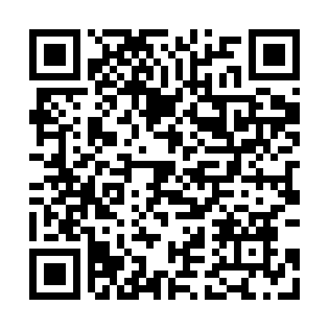
Prayer times for Briza, Czech Republic
Wed 1 May 2024 - Fri 31 May 2024
High Latitude Method: Angle Based Rule
Prayer Calculation Method: Muslim World League
Asar Calculation Method: Hanafi

Date | Day | Fajr | Sunrise | Dhuhr | Asr | Maghrib | Isha
1 | Wed | 3:16 | 5:38 | 1:00 | 6:06 | 8:23 | 10:35
2 | Thu | 3:13 | 5:36 | 1:00 | 6:07 | 8:25 | 10:38
3 | Fri | 3:09 | 5:34 | 1:00 | 6:08 | 8:27 | 10:41
4 | Sat | 3:06 | 5:32 | 1:00 | 6:09 | 8:28 | 10:44
5 | Sun | 3:03 | 5:31 | 1:00 | 6:10 | 8:30 | 10:47
6 | Mon | 2:59 | 5:29 | 1:00 | 6:11 | 8:31 | 10:50
7 | Tue | 2:56 | 5:27 | 1:00 | 6:12 | 8:33 | 10:53
8 | Wed | 2:53 | 5:26 | 1:00 | 6:13 | 8:34 | 10:56
9 | Thu | 2:49 | 5:24 | 1:00 | 6:14 | 8:36 | 10:59
10 | Fri | 2:46 | 5:23 | 1:00 | 6:14 | 8:37 | 11:02
11 | Sat | 2:44 | 5:21 | 1:00 | 6:15 | 8:39 | 11:05
12 | Sun | 2:44 | 5:20 | 12:59 | 6:16 | 8:40 | 11:07
13 | Mon | 2:43 | 5:18 | 12:59 | 6:17 | 8:42 | 11:08
14 | Tue | 2:43 | 5:17 | 12:59 | 6:18 | 8:43 | 11:09
15 | Wed | 2:42 | 5:15 | 1:00 | 6:19 | 8:44 | 11:09
16 | Thu | 2:41 | 5:14 | 1:00 | 6:20 | 8:46 | 11:10
17 | Fri | 2:41 | 5:13 | 1:00 | 6:20 | 8:47 | 11:10
18 | Sat | 2:40 | 5:11 | 1:00 | 6:21 | 8:49 | 11:11
19 | Sun | 2:40 | 5:10 | 1:00 | 6:22 | 8:50 | 11:12
20 | Mon | 2:40 | 5:09 | 1:00 | 6:23 | 8:51 | 11:12
21 | Tue | 2:39 | 5:08 | 1:00 | 6:24 | 8:53 | 11:13
22 | Wed | 2:39 | 5:06 | 1:00 | 6:24 | 8:54 | 11:13
23 | Thu | 2:38 | 5:05 | 1:00 | 6:25 | 8:55 | 11:14
24 | Fri | 2:38 | 5:04 | 1:00 | 6:26 | 8:56 | 11:15
25 | Sat | 2:37 | 5:03 | 1:00 | 6:27 | 8:58 | 11:15
26 | Sun | 2:37 | 5:02 | 1:00 | 6:27 | 8:59 | 11:16
27 | Mon | 2:37 | 5:01 | 1:00 | 6:28 | 9:00 | 11:16
28 | Tue | 2:37 | 5:00 | 1:00 | 6:29 | 9:01 | 11:17
29 | Wed | 2:36 | 4:59 | 1:01 | 6:29 | 9:02 | 11:18
30 | Thu | 2:36 | 4:59 | 1:01 | 6:30 | 9:03 | 11:18
31 | Fri | 2:36 | 4:58 | 1:01 | 6:31 | 9:05 | 11:19
Prayer times provided by https://www.salahtimes.com

