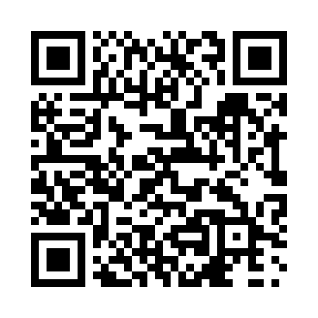
Prayer times for Ikualajuuq, Quebec, Canada
Mon 1 Jul 2024 - Wed 31 Jul 2024
High Latitude Method: Angle Based Rule
Prayer Calculation Method: Islamic Society of North America
Asar Calculation Method: Hanafi

Date | Day | Fajr | Sunrise | Dhuhr | Asr | Maghrib | Isha
1 | Mon | 2:13 | 3:19 | 1:07 | 7:13 | 10:55 | 12:01
2 | Tue | 2:14 | 3:20 | 1:07 | 7:13 | 10:54 | 12:01
3 | Wed | 2:15 | 3:22 | 1:08 | 7:13 | 10:53 | 12:00
4 | Thu | 2:15 | 3:23 | 1:08 | 7:12 | 10:51 | 11:59
5 | Fri | 2:16 | 3:25 | 1:08 | 7:12 | 10:50 | 11:59
6 | Sat | 2:17 | 3:27 | 1:08 | 7:11 | 10:48 | 11:58
7 | Sun | 2:18 | 3:29 | 1:08 | 7:11 | 10:47 | 11:57
8 | Mon | 2:19 | 3:31 | 1:08 | 7:10 | 10:45 | 11:57
9 | Tue | 2:20 | 3:33 | 1:09 | 7:10 | 10:44 | 11:56
10 | Wed | 2:22 | 3:35 | 1:09 | 7:09 | 10:42 | 11:55
11 | Thu | 2:23 | 3:37 | 1:09 | 7:08 | 10:40 | 11:54
12 | Fri | 2:24 | 3:39 | 1:09 | 7:08 | 10:38 | 11:53
13 | Sat | 2:25 | 3:41 | 1:09 | 7:07 | 10:36 | 11:52
14 | Sun | 2:26 | 3:44 | 1:09 | 7:06 | 10:34 | 11:51
15 | Mon | 2:27 | 3:46 | 1:09 | 7:05 | 10:32 | 11:50
16 | Tue | 2:29 | 3:48 | 1:09 | 7:04 | 10:29 | 11:49
17 | Wed | 2:30 | 3:51 | 1:09 | 7:03 | 10:27 | 11:48
18 | Thu | 2:31 | 3:53 | 1:10 | 7:02 | 10:25 | 11:47
19 | Fri | 2:32 | 3:56 | 1:10 | 7:01 | 10:22 | 11:46
20 | Sat | 2:34 | 3:58 | 1:10 | 7:00 | 10:20 | 11:44
21 | Sun | 2:35 | 4:01 | 1:10 | 6:59 | 10:17 | 11:43
22 | Mon | 2:36 | 4:03 | 1:10 | 6:58 | 10:15 | 11:42
23 | Tue | 2:38 | 4:06 | 1:10 | 6:57 | 10:12 | 11:41
24 | Wed | 2:39 | 4:09 | 1:10 | 6:56 | 10:10 | 11:39
25 | Thu | 2:40 | 4:11 | 1:10 | 6:54 | 10:07 | 11:38
26 | Fri | 2:41 | 4:14 | 1:10 | 6:53 | 10:04 | 11:37
27 | Sat | 2:43 | 4:16 | 1:10 | 6:52 | 10:02 | 11:35
28 | Sun | 2:44 | 4:19 | 1:10 | 6:50 | 9:59 | 11:34
29 | Mon | 2:45 | 4:22 | 1:10 | 6:49 | 9:56 | 11:33
30 | Tue | 2:47 | 4:25 | 1:10 | 6:47 | 9:53 | 11:31
31 | Wed | 2:48 | 4:27 | 1:10 | 6:46 | 9:51 | 11:30
Prayer times provided by https://www.salahtimes.com

