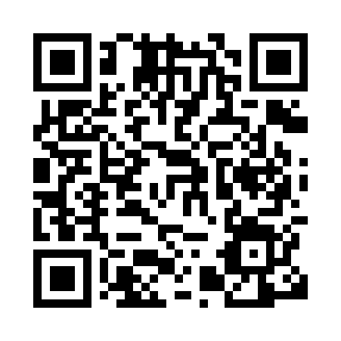
Prayer times for Neuss, North Rhine-Westphalia, Germany
Wed 1 May 2024 - Fri 31 May 2024
High Latitude Method: Angle Based Rule
Prayer Calculation Method: Muslim World League
Asar Calculation Method: Shafi

Date | Day | Fajr | Sunrise | Dhuhr | Asr | Maghrib | Isha
1 | Wed | 3:38 | 6:05 | 1:30 | 5:33 | 8:56 | 11:13
2 | Thu | 3:34 | 6:03 | 1:30 | 5:34 | 8:58 | 11:16
3 | Fri | 3:31 | 6:02 | 1:30 | 5:34 | 8:59 | 11:19
4 | Sat | 3:27 | 6:00 | 1:30 | 5:35 | 9:01 | 11:22
5 | Sun | 3:23 | 5:58 | 1:30 | 5:36 | 9:03 | 11:25
6 | Mon | 3:20 | 5:56 | 1:30 | 5:36 | 9:04 | 11:29
7 | Tue | 3:16 | 5:55 | 1:30 | 5:37 | 9:06 | 11:32
8 | Wed | 3:15 | 5:53 | 1:30 | 5:37 | 9:07 | 11:35
9 | Thu | 3:15 | 5:51 | 1:30 | 5:38 | 9:09 | 11:37
10 | Fri | 3:14 | 5:50 | 1:30 | 5:39 | 9:10 | 11:38
11 | Sat | 3:13 | 5:48 | 1:30 | 5:39 | 9:12 | 11:38
12 | Sun | 3:13 | 5:46 | 1:30 | 5:40 | 9:13 | 11:39
13 | Mon | 3:12 | 5:45 | 1:30 | 5:40 | 9:15 | 11:39
14 | Tue | 3:11 | 5:43 | 1:30 | 5:41 | 9:16 | 11:40
15 | Wed | 3:11 | 5:42 | 1:30 | 5:42 | 9:18 | 11:41
16 | Thu | 3:10 | 5:41 | 1:30 | 5:42 | 9:19 | 11:41
17 | Fri | 3:10 | 5:39 | 1:30 | 5:43 | 9:21 | 11:42
18 | Sat | 3:09 | 5:38 | 1:30 | 5:43 | 9:22 | 11:43
19 | Sun | 3:09 | 5:36 | 1:30 | 5:44 | 9:24 | 11:43
20 | Mon | 3:08 | 5:35 | 1:30 | 5:44 | 9:25 | 11:44
21 | Tue | 3:08 | 5:34 | 1:30 | 5:45 | 9:26 | 11:45
22 | Wed | 3:07 | 5:33 | 1:30 | 5:45 | 9:28 | 11:45
23 | Thu | 3:07 | 5:32 | 1:30 | 5:46 | 9:29 | 11:46
24 | Fri | 3:06 | 5:30 | 1:30 | 5:47 | 9:30 | 11:46
25 | Sat | 3:06 | 5:29 | 1:30 | 5:47 | 9:32 | 11:47
26 | Sun | 3:06 | 5:28 | 1:30 | 5:48 | 9:33 | 11:48
27 | Mon | 3:05 | 5:27 | 1:30 | 5:48 | 9:34 | 11:48
28 | Tue | 3:05 | 5:26 | 1:31 | 5:49 | 9:35 | 11:49
29 | Wed | 3:05 | 5:25 | 1:31 | 5:49 | 9:37 | 11:49
30 | Thu | 3:04 | 5:25 | 1:31 | 5:50 | 9:38 | 11:50
31 | Fri | 3:04 | 5:24 | 1:31 | 5:50 | 9:39 | 11:51
Prayer times provided by https://www.salahtimes.com

