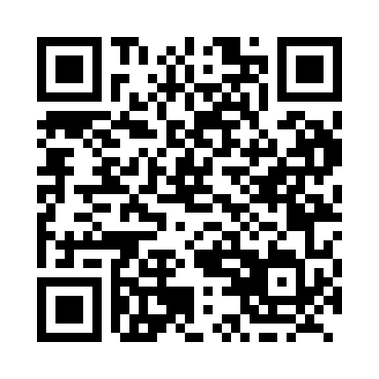
Prayer times for Charles, Manitoba, Canada
Mon 1 Jul 2024 - Wed 31 Jul 2024
High Latitude Method: Angle Based Rule
Prayer Calculation Method: Islamic Society of North America
Asar Calculation Method: Hanafi

Date | Day | Fajr | Sunrise | Dhuhr | Asr | Maghrib | Isha
1 | Mon | 3:27 | 5:07 | 1:48 | 7:34 | 10:29 | 12:09
2 | Tue | 3:28 | 5:07 | 1:48 | 7:34 | 10:29 | 12:08
3 | Wed | 3:28 | 5:08 | 1:48 | 7:34 | 10:28 | 12:08
4 | Thu | 3:29 | 5:09 | 1:49 | 7:33 | 10:28 | 12:08
5 | Fri | 3:29 | 5:10 | 1:49 | 7:33 | 10:27 | 12:08
6 | Sat | 3:30 | 5:11 | 1:49 | 7:33 | 10:26 | 12:07
7 | Sun | 3:31 | 5:13 | 1:49 | 7:33 | 10:25 | 12:07
8 | Mon | 3:31 | 5:14 | 1:49 | 7:32 | 10:24 | 12:07
9 | Tue | 3:32 | 5:15 | 1:49 | 7:32 | 10:23 | 12:06
10 | Wed | 3:33 | 5:16 | 1:50 | 7:31 | 10:22 | 12:06
11 | Thu | 3:33 | 5:18 | 1:50 | 7:31 | 10:21 | 12:05
12 | Fri | 3:34 | 5:19 | 1:50 | 7:30 | 10:20 | 12:05
13 | Sat | 3:35 | 5:20 | 1:50 | 7:30 | 10:19 | 12:04
14 | Sun | 3:36 | 5:22 | 1:50 | 7:29 | 10:18 | 12:04
15 | Mon | 3:36 | 5:23 | 1:50 | 7:29 | 10:16 | 12:03
16 | Tue | 3:37 | 5:25 | 1:50 | 7:28 | 10:15 | 12:02
17 | Wed | 3:38 | 5:26 | 1:50 | 7:27 | 10:14 | 12:02
18 | Thu | 3:39 | 5:28 | 1:50 | 7:26 | 10:12 | 12:01
19 | Fri | 3:40 | 5:29 | 1:50 | 7:26 | 10:11 | 12:00
20 | Sat | 3:40 | 5:31 | 1:50 | 7:25 | 10:09 | 12:00
21 | Sun | 3:41 | 5:32 | 1:51 | 7:24 | 10:08 | 11:59
22 | Mon | 3:42 | 5:34 | 1:51 | 7:23 | 10:06 | 11:58
23 | Tue | 3:43 | 5:36 | 1:51 | 7:22 | 10:05 | 11:57
24 | Wed | 3:44 | 5:38 | 1:51 | 7:21 | 10:03 | 11:57
25 | Thu | 3:45 | 5:39 | 1:51 | 7:20 | 10:01 | 11:56
26 | Fri | 3:46 | 5:41 | 1:51 | 7:19 | 9:59 | 11:55
27 | Sat | 3:46 | 5:43 | 1:51 | 7:18 | 9:58 | 11:54
28 | Sun | 3:47 | 5:44 | 1:51 | 7:17 | 9:56 | 11:53
29 | Mon | 3:48 | 5:46 | 1:51 | 7:16 | 9:54 | 11:52
30 | Tue | 3:49 | 5:48 | 1:50 | 7:15 | 9:52 | 11:51
31 | Wed | 3:50 | 5:50 | 1:50 | 7:14 | 9:50 | 11:50
Prayer times provided by https://www.salahtimes.com

