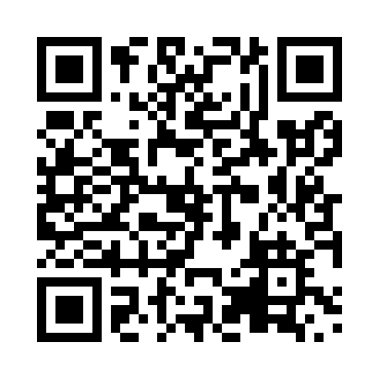
Prayer times for Tobermory, Ontario, Canada
Sat 1 Jun 2024 - Sun 30 Jun 2024
High Latitude Method: Angle Based Rule
Prayer Calculation Method: Islamic Society of North America
Asar Calculation Method: Hanafi

Date | Day | Fajr | Sunrise | Dhuhr | Asr | Maghrib | Isha
1 | Sat | 3:49 | 5:42 | 1:25 | 6:45 | 9:08 | 11:01
2 | Sun | 3:48 | 5:41 | 1:25 | 6:45 | 9:08 | 11:02
3 | Mon | 3:47 | 5:41 | 1:25 | 6:46 | 9:09 | 11:03
4 | Tue | 3:46 | 5:41 | 1:25 | 6:46 | 9:10 | 11:05
5 | Wed | 3:45 | 5:40 | 1:25 | 6:47 | 9:11 | 11:06
6 | Thu | 3:45 | 5:40 | 1:25 | 6:47 | 9:11 | 11:07
7 | Fri | 3:44 | 5:39 | 1:26 | 6:48 | 9:12 | 11:08
8 | Sat | 3:43 | 5:39 | 1:26 | 6:48 | 9:13 | 11:09
9 | Sun | 3:43 | 5:39 | 1:26 | 6:49 | 9:13 | 11:10
10 | Mon | 3:42 | 5:39 | 1:26 | 6:49 | 9:14 | 11:11
11 | Tue | 3:42 | 5:39 | 1:26 | 6:49 | 9:15 | 11:12
12 | Wed | 3:41 | 5:38 | 1:27 | 6:50 | 9:15 | 11:12
13 | Thu | 3:41 | 5:38 | 1:27 | 6:50 | 9:16 | 11:13
14 | Fri | 3:41 | 5:38 | 1:27 | 6:50 | 9:16 | 11:14
15 | Sat | 3:41 | 5:38 | 1:27 | 6:51 | 9:16 | 11:14
16 | Sun | 3:40 | 5:38 | 1:28 | 6:51 | 9:17 | 11:15
17 | Mon | 3:40 | 5:38 | 1:28 | 6:51 | 9:17 | 11:15
18 | Tue | 3:40 | 5:39 | 1:28 | 6:52 | 9:17 | 11:16
19 | Wed | 3:40 | 5:39 | 1:28 | 6:52 | 9:18 | 11:16
20 | Thu | 3:41 | 5:39 | 1:28 | 6:52 | 9:18 | 11:16
21 | Fri | 3:41 | 5:39 | 1:29 | 6:52 | 9:18 | 11:16
22 | Sat | 3:41 | 5:39 | 1:29 | 6:52 | 9:18 | 11:16
23 | Sun | 3:41 | 5:40 | 1:29 | 6:53 | 9:18 | 11:17
24 | Mon | 3:42 | 5:40 | 1:29 | 6:53 | 9:19 | 11:16
25 | Tue | 3:42 | 5:40 | 1:29 | 6:53 | 9:19 | 11:16
26 | Wed | 3:43 | 5:41 | 1:30 | 6:53 | 9:19 | 11:16
27 | Thu | 3:44 | 5:41 | 1:30 | 6:53 | 9:19 | 11:16
28 | Fri | 3:44 | 5:42 | 1:30 | 6:53 | 9:18 | 11:16
29 | Sat | 3:45 | 5:42 | 1:30 | 6:53 | 9:18 | 11:15
30 | Sun | 3:46 | 5:43 | 1:31 | 6:53 | 9:18 | 11:15
Prayer times provided by https://www.salahtimes.com

