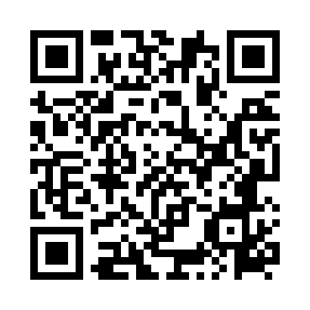
Prayer times for Szobiszowice, Poland
Wed 1 May 2024 - Fri 31 May 2024
High Latitude Method: Angle Based Rule
Prayer Calculation Method: Muslim World League
Asar Calculation Method: Hanafi

Date | Day | Fajr | Sunrise | Dhuhr | Asr | Maghrib | Isha
1 | Wed | 2:58 | 5:20 | 12:42 | 5:48 | 8:05 | 10:17
2 | Thu | 2:55 | 5:18 | 12:42 | 5:49 | 8:07 | 10:20
3 | Fri | 2:52 | 5:17 | 12:42 | 5:50 | 8:09 | 10:23
4 | Sat | 2:49 | 5:15 | 12:42 | 5:51 | 8:10 | 10:26
5 | Sun | 2:45 | 5:13 | 12:42 | 5:52 | 8:12 | 10:28
6 | Mon | 2:42 | 5:11 | 12:42 | 5:53 | 8:13 | 10:31
7 | Tue | 2:39 | 5:10 | 12:42 | 5:54 | 8:15 | 10:34
8 | Wed | 2:35 | 5:08 | 12:42 | 5:55 | 8:16 | 10:37
9 | Thu | 2:32 | 5:07 | 12:42 | 5:56 | 8:18 | 10:40
10 | Fri | 2:28 | 5:05 | 12:42 | 5:56 | 8:19 | 10:43
11 | Sat | 2:27 | 5:03 | 12:42 | 5:57 | 8:21 | 10:46
12 | Sun | 2:26 | 5:02 | 12:42 | 5:58 | 8:22 | 10:49
13 | Mon | 2:25 | 5:00 | 12:42 | 5:59 | 8:24 | 10:50
14 | Tue | 2:25 | 4:59 | 12:42 | 6:00 | 8:25 | 10:51
15 | Wed | 2:24 | 4:58 | 12:42 | 6:01 | 8:26 | 10:51
16 | Thu | 2:24 | 4:56 | 12:42 | 6:02 | 8:28 | 10:52
17 | Fri | 2:23 | 4:55 | 12:42 | 6:02 | 8:29 | 10:52
18 | Sat | 2:23 | 4:54 | 12:42 | 6:03 | 8:31 | 10:53
19 | Sun | 2:22 | 4:52 | 12:42 | 6:04 | 8:32 | 10:54
20 | Mon | 2:22 | 4:51 | 12:42 | 6:05 | 8:33 | 10:54
21 | Tue | 2:21 | 4:50 | 12:42 | 6:06 | 8:35 | 10:55
22 | Wed | 2:21 | 4:49 | 12:42 | 6:06 | 8:36 | 10:56
23 | Thu | 2:20 | 4:48 | 12:42 | 6:07 | 8:37 | 10:56
24 | Fri | 2:20 | 4:47 | 12:42 | 6:08 | 8:38 | 10:57
25 | Sat | 2:20 | 4:45 | 12:42 | 6:09 | 8:40 | 10:57
26 | Sun | 2:19 | 4:44 | 12:42 | 6:09 | 8:41 | 10:58
27 | Mon | 2:19 | 4:44 | 12:42 | 6:10 | 8:42 | 10:58
28 | Tue | 2:19 | 4:43 | 12:43 | 6:11 | 8:43 | 10:59
29 | Wed | 2:18 | 4:42 | 12:43 | 6:11 | 8:44 | 11:00
30 | Thu | 2:18 | 4:41 | 12:43 | 6:12 | 8:45 | 11:00
31 | Fri | 2:18 | 4:40 | 12:43 | 6:13 | 8:46 | 11:01
Prayer times provided by https://www.salahtimes.com

