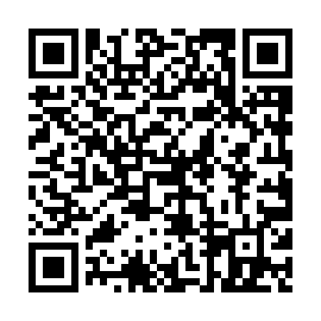
Prayer times for Campbell's Bay, Quebec, Canada
Mon 1 Jul 2024 - Wed 31 Jul 2024
High Latitude Method: Angle Based Rule
Prayer Calculation Method: Islamic Society of North America
Asar Calculation Method: Hanafi

Date | Day | Fajr | Sunrise | Dhuhr | Asr | Maghrib | Isha
1 | Mon | 3:22 | 5:21 | 1:10 | 6:34 | 9:00 | 10:58
2 | Tue | 3:23 | 5:22 | 1:11 | 6:34 | 8:59 | 10:58
3 | Wed | 3:24 | 5:22 | 1:11 | 6:34 | 8:59 | 10:57
4 | Thu | 3:25 | 5:23 | 1:11 | 6:34 | 8:59 | 10:56
5 | Fri | 3:26 | 5:24 | 1:11 | 6:34 | 8:58 | 10:56
6 | Sat | 3:27 | 5:24 | 1:11 | 6:33 | 8:58 | 10:55
7 | Sun | 3:29 | 5:25 | 1:11 | 6:33 | 8:58 | 10:54
8 | Mon | 3:30 | 5:26 | 1:12 | 6:33 | 8:57 | 10:53
9 | Tue | 3:31 | 5:27 | 1:12 | 6:33 | 8:57 | 10:52
10 | Wed | 3:32 | 5:28 | 1:12 | 6:33 | 8:56 | 10:51
11 | Thu | 3:34 | 5:28 | 1:12 | 6:32 | 8:55 | 10:50
12 | Fri | 3:35 | 5:29 | 1:12 | 6:32 | 8:55 | 10:48
13 | Sat | 3:37 | 5:30 | 1:12 | 6:32 | 8:54 | 10:47
14 | Sun | 3:38 | 5:31 | 1:12 | 6:31 | 8:53 | 10:46
15 | Mon | 3:40 | 5:32 | 1:12 | 6:31 | 8:53 | 10:44
16 | Tue | 3:41 | 5:33 | 1:13 | 6:31 | 8:52 | 10:43
17 | Wed | 3:43 | 5:34 | 1:13 | 6:30 | 8:51 | 10:42
18 | Thu | 3:45 | 5:35 | 1:13 | 6:30 | 8:50 | 10:40
19 | Fri | 3:46 | 5:36 | 1:13 | 6:29 | 8:49 | 10:39
20 | Sat | 3:48 | 5:37 | 1:13 | 6:29 | 8:48 | 10:37
21 | Sun | 3:49 | 5:38 | 1:13 | 6:28 | 8:47 | 10:35
22 | Mon | 3:51 | 5:39 | 1:13 | 6:28 | 8:46 | 10:34
23 | Tue | 3:53 | 5:40 | 1:13 | 6:27 | 8:45 | 10:32
24 | Wed | 3:55 | 5:41 | 1:13 | 6:27 | 8:44 | 10:30
25 | Thu | 3:56 | 5:42 | 1:13 | 6:26 | 8:43 | 10:29
26 | Fri | 3:58 | 5:43 | 1:13 | 6:25 | 8:42 | 10:27
27 | Sat | 4:00 | 5:45 | 1:13 | 6:25 | 8:41 | 10:25
28 | Sun | 4:02 | 5:46 | 1:13 | 6:24 | 8:40 | 10:23
29 | Mon | 4:03 | 5:47 | 1:13 | 6:23 | 8:38 | 10:21
30 | Tue | 4:05 | 5:48 | 1:13 | 6:22 | 8:37 | 10:20
31 | Wed | 4:07 | 5:49 | 1:13 | 6:22 | 8:36 | 10:18
Prayer times provided by https://www.salahtimes.com

