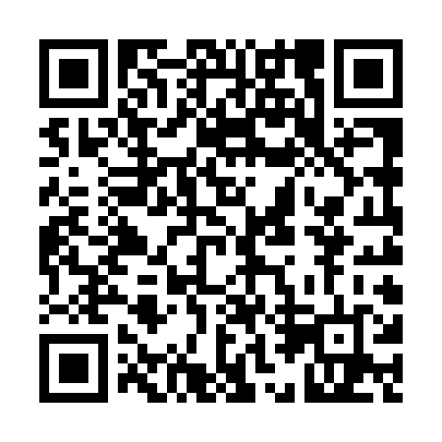
Prayer times for Little Salmon, Yukon, Canada
Wed 1 May 2024 - Fri 31 May 2024
High Latitude Method: Angle Based Rule
Prayer Calculation Method: Islamic Society of North America
Asar Calculation Method: Hanafi

Date | Day | Fajr | Sunrise | Dhuhr | Asr | Maghrib | Isha
1 | Wed | 3:53 | 5:46 | 2:00 | 7:21 | 10:15 | 12:07
2 | Thu | 3:52 | 5:43 | 2:00 | 7:23 | 10:17 | 12:09
3 | Fri | 3:50 | 5:40 | 2:00 | 7:24 | 10:20 | 12:10
4 | Sat | 3:49 | 5:37 | 1:59 | 7:26 | 10:23 | 12:12
5 | Sun | 3:47 | 5:34 | 1:59 | 7:27 | 10:26 | 12:13
6 | Mon | 3:46 | 5:32 | 1:59 | 7:29 | 10:29 | 12:14
7 | Tue | 3:44 | 5:29 | 1:59 | 7:30 | 10:31 | 12:16
8 | Wed | 3:43 | 5:26 | 1:59 | 7:32 | 10:34 | 12:17
9 | Thu | 3:41 | 5:23 | 1:59 | 7:33 | 10:37 | 12:18
10 | Fri | 3:40 | 5:20 | 1:59 | 7:35 | 10:40 | 12:20
11 | Sat | 3:38 | 5:17 | 1:59 | 7:36 | 10:42 | 12:21
12 | Sun | 3:37 | 5:14 | 1:59 | 7:38 | 10:45 | 12:22
13 | Mon | 3:36 | 5:12 | 1:59 | 7:39 | 10:48 | 12:24
14 | Tue | 3:34 | 5:09 | 1:59 | 7:40 | 10:51 | 12:25
15 | Wed | 3:33 | 5:06 | 1:59 | 7:42 | 10:53 | 12:27
16 | Thu | 3:32 | 5:04 | 1:59 | 7:43 | 10:56 | 12:28
17 | Fri | 3:30 | 5:01 | 1:59 | 7:45 | 10:59 | 12:29
18 | Sat | 3:29 | 4:58 | 1:59 | 7:46 | 11:01 | 12:31
19 | Sun | 3:28 | 4:56 | 1:59 | 7:47 | 11:04 | 12:32
20 | Mon | 3:27 | 4:53 | 1:59 | 7:48 | 11:07 | 12:33
21 | Tue | 3:25 | 4:51 | 1:59 | 7:50 | 11:09 | 12:35
22 | Wed | 3:24 | 4:48 | 1:59 | 7:51 | 11:12 | 12:36
23 | Thu | 3:23 | 4:46 | 2:00 | 7:52 | 11:14 | 12:37
24 | Fri | 3:22 | 4:44 | 2:00 | 7:53 | 11:17 | 12:38
25 | Sat | 3:21 | 4:42 | 2:00 | 7:54 | 11:19 | 12:40
26 | Sun | 3:20 | 4:39 | 2:00 | 7:55 | 11:22 | 12:41
27 | Mon | 3:19 | 4:37 | 2:00 | 7:56 | 11:24 | 12:42
28 | Tue | 3:18 | 4:35 | 2:00 | 7:57 | 11:26 | 12:43
29 | Wed | 3:17 | 4:33 | 2:00 | 7:58 | 11:28 | 12:45
30 | Thu | 3:16 | 4:31 | 2:00 | 7:59 | 11:31 | 12:46
31 | Fri | 3:15 | 4:29 | 2:01 | 8:00 | 11:33 | 12:47
Prayer times provided by https://www.salahtimes.com

