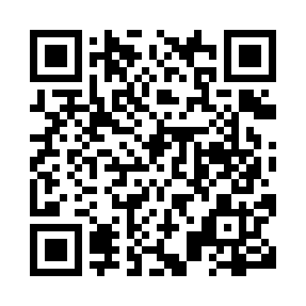
Prayer times for Annis, British Columbia, Canada
Wed 1 May 2024 - Fri 31 May 2024
High Latitude Method: Angle Based Rule
Prayer Calculation Method: Islamic Society of North America
Asar Calculation Method: Hanafi

Date | Day | Fajr | Sunrise | Dhuhr | Asr | Maghrib | Isha
1 | Wed | 3:35 | 5:29 | 12:53 | 6:00 | 8:19 | 10:13
2 | Thu | 3:33 | 5:27 | 12:53 | 6:01 | 8:20 | 10:15
3 | Fri | 3:30 | 5:25 | 12:53 | 6:02 | 8:22 | 10:18
4 | Sat | 3:27 | 5:24 | 12:53 | 6:03 | 8:23 | 10:20
5 | Sun | 3:24 | 5:22 | 12:53 | 6:04 | 8:25 | 10:23
6 | Mon | 3:22 | 5:20 | 12:53 | 6:05 | 8:26 | 10:26
7 | Tue | 3:19 | 5:19 | 12:53 | 6:06 | 8:28 | 10:28
8 | Wed | 3:16 | 5:17 | 12:53 | 6:07 | 8:29 | 10:31
9 | Thu | 3:13 | 5:15 | 12:53 | 6:08 | 8:31 | 10:34
10 | Fri | 3:11 | 5:14 | 12:53 | 6:09 | 8:33 | 10:36
11 | Sat | 3:08 | 5:12 | 12:53 | 6:10 | 8:34 | 10:39
12 | Sun | 3:05 | 5:11 | 12:53 | 6:10 | 8:36 | 10:42
13 | Mon | 3:02 | 5:09 | 12:53 | 6:11 | 8:37 | 10:44
14 | Tue | 3:00 | 5:08 | 12:53 | 6:12 | 8:38 | 10:46
15 | Wed | 3:00 | 5:06 | 12:53 | 6:13 | 8:40 | 10:46
16 | Thu | 2:59 | 5:05 | 12:53 | 6:14 | 8:41 | 10:47
17 | Fri | 2:58 | 5:03 | 12:53 | 6:15 | 8:43 | 10:48
18 | Sat | 2:58 | 5:02 | 12:53 | 6:16 | 8:44 | 10:49
19 | Sun | 2:57 | 5:01 | 12:53 | 6:16 | 8:46 | 10:49
20 | Mon | 2:56 | 5:00 | 12:53 | 6:17 | 8:47 | 10:50
21 | Tue | 2:56 | 4:58 | 12:53 | 6:18 | 8:48 | 10:51
22 | Wed | 2:55 | 4:57 | 12:53 | 6:19 | 8:50 | 10:51
23 | Thu | 2:55 | 4:56 | 12:53 | 6:19 | 8:51 | 10:52
24 | Fri | 2:54 | 4:55 | 12:53 | 6:20 | 8:52 | 10:53
25 | Sat | 2:54 | 4:54 | 12:53 | 6:21 | 8:53 | 10:54
26 | Sun | 2:53 | 4:53 | 12:53 | 6:22 | 8:55 | 10:54
27 | Mon | 2:53 | 4:52 | 12:54 | 6:22 | 8:56 | 10:55
28 | Tue | 2:53 | 4:51 | 12:54 | 6:23 | 8:57 | 10:55
29 | Wed | 2:52 | 4:50 | 12:54 | 6:24 | 8:58 | 10:56
30 | Thu | 2:52 | 4:49 | 12:54 | 6:24 | 8:59 | 10:57
31 | Fri | 2:51 | 4:49 | 12:54 | 6:25 | 9:00 | 10:57
Prayer times provided by https://www.salahtimes.com

