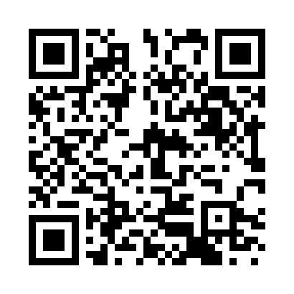
Prayer times for Arta Terme, Italy
Wed 1 May 2024 - Fri 31 May 2024
High Latitude Method: Angle Based Rule
Prayer Calculation Method: Muslim World League
Asar Calculation Method: Hanafi

Date | Day | Fajr | Sunrise | Dhuhr | Asr | Maghrib | Isha
1 | Wed | 3:50 | 5:53 | 1:05 | 6:07 | 8:17 | 10:12
2 | Thu | 3:48 | 5:52 | 1:05 | 6:08 | 8:19 | 10:14
3 | Fri | 3:45 | 5:50 | 1:05 | 6:08 | 8:20 | 10:17
4 | Sat | 3:43 | 5:49 | 1:05 | 6:09 | 8:21 | 10:19
5 | Sun | 3:41 | 5:47 | 1:05 | 6:10 | 8:23 | 10:21
6 | Mon | 3:38 | 5:46 | 1:05 | 6:11 | 8:24 | 10:23
7 | Tue | 3:36 | 5:44 | 1:04 | 6:11 | 8:25 | 10:25
8 | Wed | 3:33 | 5:43 | 1:04 | 6:12 | 8:27 | 10:27
9 | Thu | 3:31 | 5:41 | 1:04 | 6:13 | 8:28 | 10:29
10 | Fri | 3:29 | 5:40 | 1:04 | 6:14 | 8:29 | 10:31
11 | Sat | 3:26 | 5:39 | 1:04 | 6:14 | 8:30 | 10:34
12 | Sun | 3:24 | 5:38 | 1:04 | 6:15 | 8:32 | 10:36
13 | Mon | 3:22 | 5:36 | 1:04 | 6:16 | 8:33 | 10:38
14 | Tue | 3:20 | 5:35 | 1:04 | 6:17 | 8:34 | 10:40
15 | Wed | 3:17 | 5:34 | 1:04 | 6:17 | 8:35 | 10:42
16 | Thu | 3:15 | 5:33 | 1:04 | 6:18 | 8:37 | 10:44
17 | Fri | 3:13 | 5:32 | 1:04 | 6:19 | 8:38 | 10:46
18 | Sat | 3:11 | 5:30 | 1:04 | 6:19 | 8:39 | 10:49
19 | Sun | 3:08 | 5:29 | 1:04 | 6:20 | 8:40 | 10:51
20 | Mon | 3:06 | 5:28 | 1:04 | 6:21 | 8:41 | 10:53
21 | Tue | 3:04 | 5:27 | 1:05 | 6:22 | 8:42 | 10:55
22 | Wed | 3:02 | 5:26 | 1:05 | 6:22 | 8:43 | 10:57
23 | Thu | 3:00 | 5:25 | 1:05 | 6:23 | 8:45 | 10:59
24 | Fri | 2:58 | 5:25 | 1:05 | 6:23 | 8:46 | 11:01
25 | Sat | 2:56 | 5:24 | 1:05 | 6:24 | 8:47 | 11:03
26 | Sun | 2:54 | 5:23 | 1:05 | 6:25 | 8:48 | 11:05
27 | Mon | 2:52 | 5:22 | 1:05 | 6:25 | 8:49 | 11:07
28 | Tue | 2:50 | 5:21 | 1:05 | 6:26 | 8:50 | 11:09
29 | Wed | 2:48 | 5:21 | 1:05 | 6:27 | 8:51 | 11:11
30 | Thu | 2:47 | 5:20 | 1:06 | 6:27 | 8:52 | 11:13
31 | Fri | 2:47 | 5:19 | 1:06 | 6:28 | 8:52 | 11:14
Prayer times provided by https://www.salahtimes.com

