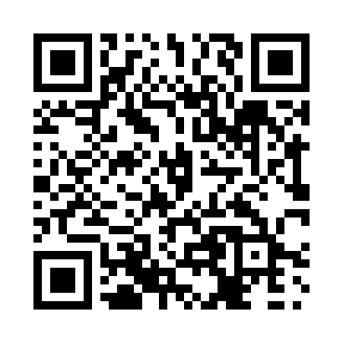
Prayer times for Kangirsuk, Quebec, Canada
Mon 1 Jul 2024 - Wed 31 Jul 2024
High Latitude Method: Angle Based Rule
Prayer Calculation Method: Islamic Society of North America
Asar Calculation Method: Hanafi

Date | Day | Fajr | Sunrise | Dhuhr | Asr | Maghrib | Isha
1 | Mon | 2:03 | 3:23 | 12:44 | 6:43 | 10:05 | 11:24
2 | Tue | 2:04 | 3:24 | 12:44 | 6:43 | 10:04 | 11:24
3 | Wed | 2:05 | 3:25 | 12:45 | 6:42 | 10:03 | 11:24
4 | Thu | 2:06 | 3:27 | 12:45 | 6:42 | 10:02 | 11:23
5 | Fri | 2:06 | 3:28 | 12:45 | 6:42 | 10:01 | 11:23
6 | Sat | 2:07 | 3:30 | 12:45 | 6:41 | 10:00 | 11:22
7 | Sun | 2:08 | 3:31 | 12:45 | 6:41 | 9:59 | 11:22
8 | Mon | 2:09 | 3:33 | 12:45 | 6:40 | 9:57 | 11:21
9 | Tue | 2:10 | 3:34 | 12:46 | 6:40 | 9:56 | 11:21
10 | Wed | 2:11 | 3:36 | 12:46 | 6:39 | 9:55 | 11:20
11 | Thu | 2:11 | 3:38 | 12:46 | 6:39 | 9:53 | 11:19
12 | Fri | 2:12 | 3:39 | 12:46 | 6:38 | 9:52 | 11:18
13 | Sat | 2:13 | 3:41 | 12:46 | 6:37 | 9:50 | 11:18
14 | Sun | 2:14 | 3:43 | 12:46 | 6:37 | 9:48 | 11:17
15 | Mon | 2:15 | 3:45 | 12:46 | 6:36 | 9:46 | 11:16
16 | Tue | 2:16 | 3:47 | 12:46 | 6:35 | 9:45 | 11:15
17 | Wed | 2:17 | 3:49 | 12:46 | 6:34 | 9:43 | 11:14
18 | Thu | 2:19 | 3:51 | 12:46 | 6:33 | 9:41 | 11:13
19 | Fri | 2:20 | 3:53 | 12:47 | 6:32 | 9:39 | 11:12
20 | Sat | 2:21 | 3:55 | 12:47 | 6:31 | 9:37 | 11:11
21 | Sun | 2:22 | 3:57 | 12:47 | 6:30 | 9:35 | 11:10
22 | Mon | 2:23 | 4:00 | 12:47 | 6:29 | 9:33 | 11:09
23 | Tue | 2:24 | 4:02 | 12:47 | 6:28 | 9:30 | 11:08
24 | Wed | 2:25 | 4:04 | 12:47 | 6:27 | 9:28 | 11:07
25 | Thu | 2:26 | 4:06 | 12:47 | 6:26 | 9:26 | 11:06
26 | Fri | 2:27 | 4:09 | 12:47 | 6:25 | 9:24 | 11:05
27 | Sat | 2:28 | 4:11 | 12:47 | 6:24 | 9:21 | 11:04
28 | Sun | 2:30 | 4:13 | 12:47 | 6:22 | 9:19 | 11:03
29 | Mon | 2:31 | 4:15 | 12:47 | 6:21 | 9:17 | 11:01
30 | Tue | 2:32 | 4:18 | 12:47 | 6:20 | 9:14 | 11:00
31 | Wed | 2:33 | 4:20 | 12:47 | 6:18 | 9:12 | 10:59
Prayer times provided by https://www.salahtimes.com

