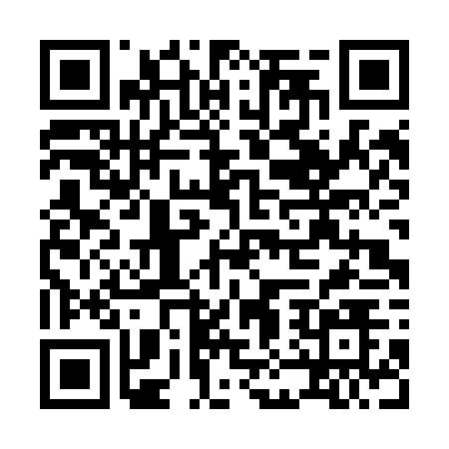
Prayer times for Barra de Santo Antonio, Brazil
Wed 1 May 2024 - Fri 31 May 2024
High Latitude Method: None
Prayer Calculation Method: Muslim World League
Asar Calculation Method: Shafi

Date | Day | Fajr | Sunrise | Dhuhr | Asr | Maghrib | Isha
1 | Wed | 4:14 | 5:26 | 11:19 | 2:40 | 5:12 | 6:20
2 | Thu | 4:14 | 5:26 | 11:19 | 2:40 | 5:12 | 6:19
3 | Fri | 4:14 | 5:26 | 11:19 | 2:40 | 5:11 | 6:19
4 | Sat | 4:14 | 5:26 | 11:19 | 2:40 | 5:11 | 6:19
5 | Sun | 4:14 | 5:26 | 11:19 | 2:40 | 5:11 | 6:19
6 | Mon | 4:14 | 5:26 | 11:19 | 2:40 | 5:11 | 6:19
7 | Tue | 4:14 | 5:27 | 11:19 | 2:39 | 5:10 | 6:19
8 | Wed | 4:14 | 5:27 | 11:18 | 2:39 | 5:10 | 6:18
9 | Thu | 4:14 | 5:27 | 11:18 | 2:39 | 5:10 | 6:18
10 | Fri | 4:14 | 5:27 | 11:18 | 2:39 | 5:10 | 6:18
11 | Sat | 4:14 | 5:27 | 11:18 | 2:39 | 5:09 | 6:18
12 | Sun | 4:14 | 5:27 | 11:18 | 2:39 | 5:09 | 6:18
13 | Mon | 4:15 | 5:28 | 11:18 | 2:39 | 5:09 | 6:18
14 | Tue | 4:15 | 5:28 | 11:18 | 2:39 | 5:09 | 6:18
15 | Wed | 4:15 | 5:28 | 11:18 | 2:39 | 5:09 | 6:18
16 | Thu | 4:15 | 5:28 | 11:18 | 2:39 | 5:09 | 6:18
17 | Fri | 4:15 | 5:28 | 11:18 | 2:39 | 5:09 | 6:18
18 | Sat | 4:15 | 5:28 | 11:18 | 2:39 | 5:08 | 6:18
19 | Sun | 4:15 | 5:29 | 11:19 | 2:39 | 5:08 | 6:18
20 | Mon | 4:15 | 5:29 | 11:19 | 2:39 | 5:08 | 6:18
21 | Tue | 4:15 | 5:29 | 11:19 | 2:39 | 5:08 | 6:18
22 | Wed | 4:15 | 5:29 | 11:19 | 2:39 | 5:08 | 6:18
23 | Thu | 4:16 | 5:30 | 11:19 | 2:39 | 5:08 | 6:18
24 | Fri | 4:16 | 5:30 | 11:19 | 2:39 | 5:08 | 6:18
25 | Sat | 4:16 | 5:30 | 11:19 | 2:39 | 5:08 | 6:18
26 | Sun | 4:16 | 5:30 | 11:19 | 2:39 | 5:08 | 6:18
27 | Mon | 4:16 | 5:30 | 11:19 | 2:39 | 5:08 | 6:18
28 | Tue | 4:16 | 5:31 | 11:19 | 2:39 | 5:08 | 6:18
29 | Wed | 4:17 | 5:31 | 11:20 | 2:39 | 5:08 | 6:18
30 | Thu | 4:17 | 5:31 | 11:20 | 2:39 | 5:08 | 6:18
31 | Fri | 4:17 | 5:31 | 11:20 | 2:40 | 5:08 | 6:18
Prayer times provided by https://www.salahtimes.com

