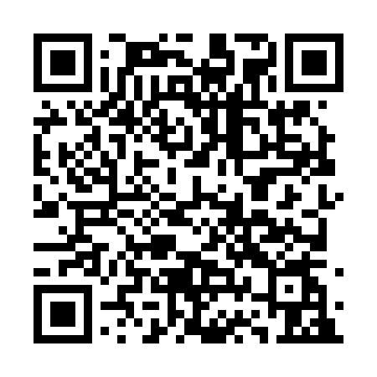
Prayer times for Beka Modibo, Cameroon
Wed 1 May 2024 - Fri 31 May 2024
High Latitude Method: None
Prayer Calculation Method: Muslim World League
Asar Calculation Method: Shafi

Date | Day | Fajr | Sunrise | Dhuhr | Asr | Maghrib | Isha
1 | Wed | 4:36 | 5:48 | 11:59 | 3:16 | 6:10 | 7:18
2 | Thu | 4:36 | 5:48 | 11:59 | 3:17 | 6:10 | 7:19
3 | Fri | 4:35 | 5:48 | 11:59 | 3:17 | 6:10 | 7:19
4 | Sat | 4:35 | 5:47 | 11:59 | 3:17 | 6:11 | 7:19
5 | Sun | 4:34 | 5:47 | 11:59 | 3:18 | 6:11 | 7:19
6 | Mon | 4:34 | 5:47 | 11:59 | 3:18 | 6:11 | 7:19
7 | Tue | 4:34 | 5:47 | 11:59 | 3:18 | 6:11 | 7:20
8 | Wed | 4:33 | 5:47 | 11:59 | 3:19 | 6:11 | 7:20
9 | Thu | 4:33 | 5:46 | 11:59 | 3:19 | 6:11 | 7:20
10 | Fri | 4:33 | 5:46 | 11:59 | 3:19 | 6:11 | 7:20
11 | Sat | 4:33 | 5:46 | 11:59 | 3:20 | 6:11 | 7:20
12 | Sun | 4:32 | 5:46 | 11:59 | 3:20 | 6:11 | 7:21
13 | Mon | 4:32 | 5:46 | 11:59 | 3:20 | 6:11 | 7:21
14 | Tue | 4:32 | 5:46 | 11:59 | 3:20 | 6:12 | 7:21
15 | Wed | 4:32 | 5:45 | 11:59 | 3:21 | 6:12 | 7:21
16 | Thu | 4:31 | 5:45 | 11:59 | 3:21 | 6:12 | 7:22
17 | Fri | 4:31 | 5:45 | 11:59 | 3:21 | 6:12 | 7:22
18 | Sat | 4:31 | 5:45 | 11:59 | 3:22 | 6:12 | 7:22
19 | Sun | 4:31 | 5:45 | 11:59 | 3:22 | 6:12 | 7:22
20 | Mon | 4:31 | 5:45 | 11:59 | 3:22 | 6:13 | 7:23
21 | Tue | 4:30 | 5:45 | 11:59 | 3:23 | 6:13 | 7:23
22 | Wed | 4:30 | 5:45 | 11:59 | 3:23 | 6:13 | 7:23
23 | Thu | 4:30 | 5:45 | 11:59 | 3:23 | 6:13 | 7:24
24 | Fri | 4:30 | 5:45 | 11:59 | 3:24 | 6:13 | 7:24
25 | Sat | 4:30 | 5:45 | 11:59 | 3:24 | 6:14 | 7:24
26 | Sun | 4:30 | 5:45 | 11:59 | 3:24 | 6:14 | 7:25
27 | Mon | 4:30 | 5:45 | 11:59 | 3:25 | 6:14 | 7:25
28 | Tue | 4:30 | 5:45 | 12:00 | 3:25 | 6:14 | 7:25
29 | Wed | 4:30 | 5:45 | 12:00 | 3:25 | 6:14 | 7:25
30 | Thu | 4:30 | 5:45 | 12:00 | 3:25 | 6:15 | 7:26
31 | Fri | 4:29 | 5:45 | 12:00 | 3:26 | 6:15 | 7:26
Prayer times provided by https://www.salahtimes.com

