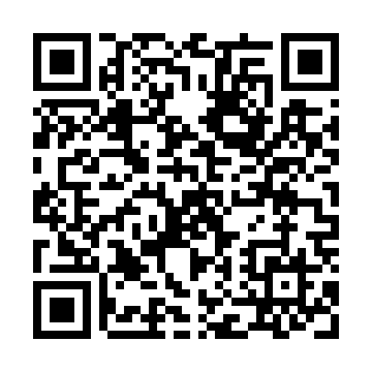
Prayer times for Clarinda Junction, Iowa, USA
Mon 1 Jul 2024 - Wed 31 Jul 2024
High Latitude Method: Angle Based Rule
Prayer Calculation Method: Islamic Society of North America
Asar Calculation Method: Shafi

Date | Day | Fajr | Sunrise | Dhuhr | Asr | Maghrib | Isha
1 | Mon | 4:13 | 5:52 | 1:24 | 5:24 | 8:56 | 10:35
2 | Tue | 4:13 | 5:53 | 1:24 | 5:25 | 8:56 | 10:35
3 | Wed | 4:14 | 5:53 | 1:24 | 5:25 | 8:55 | 10:34
4 | Thu | 4:15 | 5:54 | 1:25 | 5:25 | 8:55 | 10:34
5 | Fri | 4:16 | 5:54 | 1:25 | 5:25 | 8:55 | 10:33
6 | Sat | 4:17 | 5:55 | 1:25 | 5:25 | 8:55 | 10:33
7 | Sun | 4:18 | 5:56 | 1:25 | 5:25 | 8:54 | 10:32
8 | Mon | 4:18 | 5:56 | 1:25 | 5:25 | 8:54 | 10:32
9 | Tue | 4:19 | 5:57 | 1:25 | 5:25 | 8:53 | 10:31
10 | Wed | 4:20 | 5:58 | 1:26 | 5:25 | 8:53 | 10:30
11 | Thu | 4:21 | 5:59 | 1:26 | 5:25 | 8:52 | 10:29
12 | Fri | 4:23 | 5:59 | 1:26 | 5:25 | 8:52 | 10:29
13 | Sat | 4:24 | 6:00 | 1:26 | 5:25 | 8:51 | 10:28
14 | Sun | 4:25 | 6:01 | 1:26 | 5:25 | 8:51 | 10:27
15 | Mon | 4:26 | 6:02 | 1:26 | 5:25 | 8:50 | 10:26
16 | Tue | 4:27 | 6:02 | 1:26 | 5:25 | 8:50 | 10:25
17 | Wed | 4:28 | 6:03 | 1:26 | 5:25 | 8:49 | 10:24
18 | Thu | 4:29 | 6:04 | 1:26 | 5:25 | 8:48 | 10:23
19 | Fri | 4:31 | 6:05 | 1:26 | 5:24 | 8:47 | 10:22
20 | Sat | 4:32 | 6:06 | 1:26 | 5:24 | 8:47 | 10:20
21 | Sun | 4:33 | 6:07 | 1:26 | 5:24 | 8:46 | 10:19
22 | Mon | 4:34 | 6:07 | 1:27 | 5:24 | 8:45 | 10:18
23 | Tue | 4:36 | 6:08 | 1:27 | 5:24 | 8:44 | 10:17
24 | Wed | 4:37 | 6:09 | 1:27 | 5:24 | 8:43 | 10:15
25 | Thu | 4:38 | 6:10 | 1:27 | 5:23 | 8:42 | 10:14
26 | Fri | 4:40 | 6:11 | 1:27 | 5:23 | 8:42 | 10:13
27 | Sat | 4:41 | 6:12 | 1:27 | 5:23 | 8:41 | 10:11
28 | Sun | 4:42 | 6:13 | 1:27 | 5:22 | 8:40 | 10:10
29 | Mon | 4:44 | 6:14 | 1:26 | 5:22 | 8:39 | 10:09
30 | Tue | 4:45 | 6:15 | 1:26 | 5:22 | 8:37 | 10:07
31 | Wed | 4:46 | 6:16 | 1:26 | 5:21 | 8:36 | 10:06
Prayer times provided by https://www.salahtimes.com

