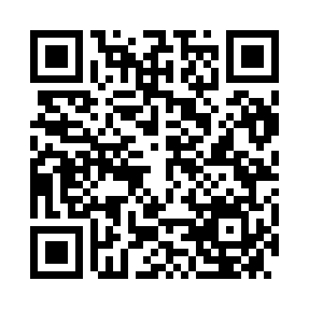
Prayer times for Barcadera, Aruba
Wed 1 May 2024 - Fri 31 May 2024
High Latitude Method: None
Prayer Calculation Method: Muslim World League
Asar Calculation Method: Shafi

Date | Day | Fajr | Sunrise | Dhuhr | Asr | Maghrib | Isha
1 | Wed | 5:06 | 6:20 | 12:37 | 3:48 | 6:54 | 8:04
2 | Thu | 5:05 | 6:19 | 12:37 | 3:49 | 6:55 | 8:05
3 | Fri | 5:04 | 6:19 | 12:37 | 3:49 | 6:55 | 8:05
4 | Sat | 5:04 | 6:18 | 12:37 | 3:50 | 6:55 | 8:05
5 | Sun | 5:03 | 6:18 | 12:37 | 3:50 | 6:55 | 8:05
6 | Mon | 5:03 | 6:18 | 12:37 | 3:51 | 6:55 | 8:06
7 | Tue | 5:03 | 6:17 | 12:36 | 3:51 | 6:56 | 8:06
8 | Wed | 5:02 | 6:17 | 12:36 | 3:52 | 6:56 | 8:07
9 | Thu | 5:02 | 6:17 | 12:36 | 3:52 | 6:56 | 8:07
10 | Fri | 5:01 | 6:16 | 12:36 | 3:53 | 6:56 | 8:07
11 | Sat | 5:01 | 6:16 | 12:36 | 3:53 | 6:57 | 8:08
12 | Sun | 5:00 | 6:16 | 12:36 | 3:54 | 6:57 | 8:08
13 | Mon | 5:00 | 6:16 | 12:36 | 3:54 | 6:57 | 8:08
14 | Tue | 5:00 | 6:15 | 12:36 | 3:55 | 6:57 | 8:09
15 | Wed | 4:59 | 6:15 | 12:36 | 3:55 | 6:58 | 8:09
16 | Thu | 4:59 | 6:15 | 12:36 | 3:56 | 6:58 | 8:09
17 | Fri | 4:59 | 6:15 | 12:36 | 3:56 | 6:58 | 8:10
18 | Sat | 4:58 | 6:15 | 12:36 | 3:57 | 6:58 | 8:10
19 | Sun | 4:58 | 6:14 | 12:36 | 3:57 | 6:59 | 8:11
20 | Mon | 4:58 | 6:14 | 12:37 | 3:57 | 6:59 | 8:11
21 | Tue | 4:57 | 6:14 | 12:37 | 3:58 | 6:59 | 8:11
22 | Wed | 4:57 | 6:14 | 12:37 | 3:58 | 6:59 | 8:12
23 | Thu | 4:57 | 6:14 | 12:37 | 3:59 | 7:00 | 8:12
24 | Fri | 4:57 | 6:14 | 12:37 | 3:59 | 7:00 | 8:13
25 | Sat | 4:56 | 6:14 | 12:37 | 4:00 | 7:00 | 8:13
26 | Sun | 4:56 | 6:14 | 12:37 | 4:00 | 7:01 | 8:13
27 | Mon | 4:56 | 6:14 | 12:37 | 4:00 | 7:01 | 8:14
28 | Tue | 4:56 | 6:14 | 12:37 | 4:01 | 7:01 | 8:14
29 | Wed | 4:56 | 6:14 | 12:37 | 4:01 | 7:01 | 8:15
30 | Thu | 4:56 | 6:13 | 12:38 | 4:02 | 7:02 | 8:15
31 | Fri | 4:56 | 6:13 | 12:38 | 4:02 | 7:02 | 8:15
Prayer times provided by https://www.salahtimes.com

