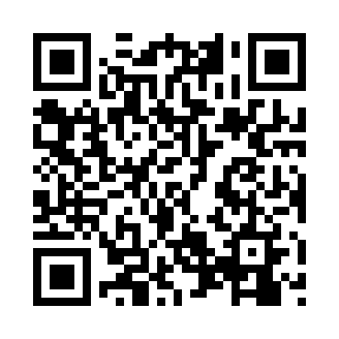
Prayer times for Kōnosu, Japan
Mon 1 Apr 2024 - Tue 30 Apr 2024
High Latitude Method: None
Prayer Calculation Method: Muslim World League
Asar Calculation Method: Shafi

Date | Day | Fajr | Sunrise | Dhuhr | Asr | Maghrib | Isha
1 | Mon | 4:01 | 5:28 | 11:46 | 3:20 | 6:04 | 7:26
2 | Tue | 3:59 | 5:27 | 11:46 | 3:20 | 6:05 | 7:27
3 | Wed | 3:58 | 5:25 | 11:45 | 3:20 | 6:06 | 7:28
4 | Thu | 3:56 | 5:24 | 11:45 | 3:20 | 6:06 | 7:29
5 | Fri | 3:55 | 5:23 | 11:45 | 3:21 | 6:07 | 7:30
6 | Sat | 3:53 | 5:21 | 11:44 | 3:21 | 6:08 | 7:31
7 | Sun | 3:51 | 5:20 | 11:44 | 3:21 | 6:09 | 7:32
8 | Mon | 3:50 | 5:18 | 11:44 | 3:21 | 6:10 | 7:33
9 | Tue | 3:48 | 5:17 | 11:44 | 3:21 | 6:11 | 7:34
10 | Wed | 3:46 | 5:16 | 11:43 | 3:22 | 6:11 | 7:35
11 | Thu | 3:45 | 5:14 | 11:43 | 3:22 | 6:12 | 7:36
12 | Fri | 3:43 | 5:13 | 11:43 | 3:22 | 6:13 | 7:38
13 | Sat | 3:42 | 5:12 | 11:43 | 3:22 | 6:14 | 7:39
14 | Sun | 3:40 | 5:10 | 11:42 | 3:22 | 6:15 | 7:40
15 | Mon | 3:38 | 5:09 | 11:42 | 3:22 | 6:16 | 7:41
16 | Tue | 3:37 | 5:08 | 11:42 | 3:23 | 6:17 | 7:42
17 | Wed | 3:35 | 5:06 | 11:42 | 3:23 | 6:17 | 7:43
18 | Thu | 3:34 | 5:05 | 11:41 | 3:23 | 6:18 | 7:44
19 | Fri | 3:32 | 5:04 | 11:41 | 3:23 | 6:19 | 7:45
20 | Sat | 3:30 | 5:02 | 11:41 | 3:23 | 6:20 | 7:46
21 | Sun | 3:29 | 5:01 | 11:41 | 3:23 | 6:21 | 7:48
22 | Mon | 3:27 | 5:00 | 11:41 | 3:23 | 6:22 | 7:49
23 | Tue | 3:26 | 4:59 | 11:40 | 3:24 | 6:22 | 7:50
24 | Wed | 3:24 | 4:57 | 11:40 | 3:24 | 6:23 | 7:51
25 | Thu | 3:23 | 4:56 | 11:40 | 3:24 | 6:24 | 7:52
26 | Fri | 3:21 | 4:55 | 11:40 | 3:24 | 6:25 | 7:53
27 | Sat | 3:20 | 4:54 | 11:40 | 3:24 | 6:26 | 7:54
28 | Sun | 3:18 | 4:53 | 11:39 | 3:24 | 6:27 | 7:56
29 | Mon | 3:17 | 4:52 | 11:39 | 3:24 | 6:28 | 7:57
30 | Tue | 3:15 | 4:50 | 11:39 | 3:24 | 6:28 | 7:58
Prayer times provided by https://www.salahtimes.com

