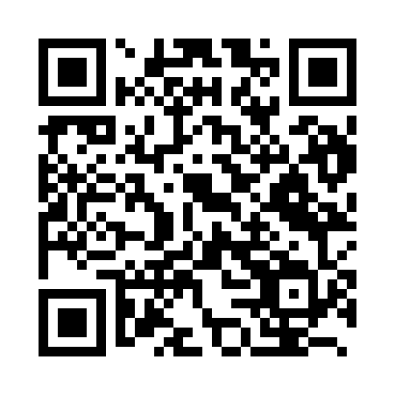
Prayer times for Nakanoshima, Japan
Wed 1 May 2024 - Fri 31 May 2024
High Latitude Method: None
Prayer Calculation Method: Muslim World League
Asar Calculation Method: Shafi

Date | Day | Fajr | Sunrise | Dhuhr | Asr | Maghrib | Isha
1 | Wed | 4:11 | 5:38 | 12:18 | 3:54 | 6:58 | 8:19
2 | Thu | 4:10 | 5:37 | 12:18 | 3:54 | 6:58 | 8:20
3 | Fri | 4:09 | 5:36 | 12:17 | 3:54 | 6:59 | 8:21
4 | Sat | 4:08 | 5:35 | 12:17 | 3:54 | 7:00 | 8:22
5 | Sun | 4:07 | 5:35 | 12:17 | 3:54 | 7:00 | 8:23
6 | Mon | 4:06 | 5:34 | 12:17 | 3:54 | 7:01 | 8:24
7 | Tue | 4:05 | 5:33 | 12:17 | 3:54 | 7:02 | 8:25
8 | Wed | 4:04 | 5:32 | 12:17 | 3:54 | 7:02 | 8:25
9 | Thu | 4:03 | 5:31 | 12:17 | 3:54 | 7:03 | 8:26
10 | Fri | 4:02 | 5:31 | 12:17 | 3:53 | 7:04 | 8:27
11 | Sat | 4:01 | 5:30 | 12:17 | 3:53 | 7:04 | 8:28
12 | Sun | 4:00 | 5:29 | 12:17 | 3:53 | 7:05 | 8:29
13 | Mon | 3:59 | 5:29 | 12:17 | 3:53 | 7:05 | 8:30
14 | Tue | 3:58 | 5:28 | 12:17 | 3:53 | 7:06 | 8:31
15 | Wed | 3:57 | 5:27 | 12:17 | 3:53 | 7:07 | 8:32
16 | Thu | 3:56 | 5:27 | 12:17 | 3:53 | 7:07 | 8:32
17 | Fri | 3:55 | 5:26 | 12:17 | 3:53 | 7:08 | 8:33
18 | Sat | 3:55 | 5:26 | 12:17 | 3:53 | 7:09 | 8:34
19 | Sun | 3:54 | 5:25 | 12:17 | 3:53 | 7:09 | 8:35
20 | Mon | 3:53 | 5:25 | 12:17 | 3:53 | 7:10 | 8:36
21 | Tue | 3:52 | 5:24 | 12:17 | 3:53 | 7:10 | 8:37
22 | Wed | 3:52 | 5:24 | 12:17 | 3:53 | 7:11 | 8:38
23 | Thu | 3:51 | 5:23 | 12:17 | 3:53 | 7:12 | 8:38
24 | Fri | 3:50 | 5:23 | 12:17 | 3:53 | 7:12 | 8:39
25 | Sat | 3:50 | 5:22 | 12:18 | 3:53 | 7:13 | 8:40
26 | Sun | 3:49 | 5:22 | 12:18 | 3:54 | 7:13 | 8:41
27 | Mon | 3:48 | 5:22 | 12:18 | 3:54 | 7:14 | 8:42
28 | Tue | 3:48 | 5:21 | 12:18 | 3:54 | 7:15 | 8:42
29 | Wed | 3:47 | 5:21 | 12:18 | 3:54 | 7:15 | 8:43
30 | Thu | 3:47 | 5:21 | 12:18 | 3:54 | 7:16 | 8:44
31 | Fri | 3:46 | 5:21 | 12:18 | 3:54 | 7:16 | 8:45
Prayer times provided by https://www.salahtimes.com

