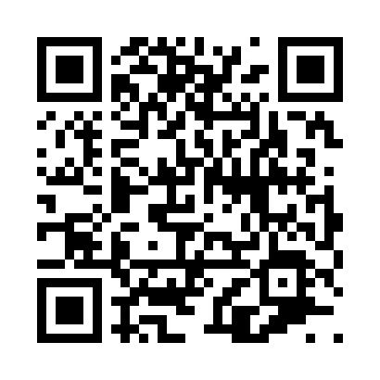
Prayer times for Corliss, Pennsylvania, USA
Mon 1 Apr 2024 - Tue 30 Apr 2024
High Latitude Method: Angle Based Rule
Prayer Calculation Method: Islamic Society of North America
Asar Calculation Method: Shafi

Date | Day | Fajr | Sunrise | Dhuhr | Asr | Maghrib | Isha
1 | Mon | 5:46 | 7:03 | 1:24 | 4:59 | 7:45 | 9:02
2 | Tue | 5:45 | 7:01 | 1:24 | 4:59 | 7:46 | 9:03
3 | Wed | 5:43 | 7:00 | 1:23 | 5:00 | 7:48 | 9:05
4 | Thu | 5:41 | 6:58 | 1:23 | 5:00 | 7:49 | 9:06
5 | Fri | 5:39 | 6:57 | 1:23 | 5:01 | 7:50 | 9:07
6 | Sat | 5:37 | 6:55 | 1:22 | 5:01 | 7:51 | 9:08
7 | Sun | 5:36 | 6:53 | 1:22 | 5:01 | 7:52 | 9:10
8 | Mon | 5:34 | 6:52 | 1:22 | 5:02 | 7:53 | 9:11
9 | Tue | 5:32 | 6:50 | 1:22 | 5:02 | 7:54 | 9:12
10 | Wed | 5:30 | 6:49 | 1:21 | 5:02 | 7:55 | 9:13
11 | Thu | 5:28 | 6:47 | 1:21 | 5:03 | 7:56 | 9:15
12 | Fri | 5:27 | 6:46 | 1:21 | 5:03 | 7:57 | 9:16
13 | Sat | 5:25 | 6:44 | 1:21 | 5:03 | 7:58 | 9:17
14 | Sun | 5:23 | 6:42 | 1:20 | 5:04 | 7:59 | 9:19
15 | Mon | 5:21 | 6:41 | 1:20 | 5:04 | 8:00 | 9:20
16 | Tue | 5:19 | 6:39 | 1:20 | 5:04 | 8:01 | 9:21
17 | Wed | 5:18 | 6:38 | 1:20 | 5:05 | 8:02 | 9:22
18 | Thu | 5:16 | 6:36 | 1:19 | 5:05 | 8:03 | 9:24
19 | Fri | 5:14 | 6:35 | 1:19 | 5:05 | 8:04 | 9:25
20 | Sat | 5:12 | 6:34 | 1:19 | 5:05 | 8:05 | 9:26
21 | Sun | 5:11 | 6:32 | 1:19 | 5:06 | 8:06 | 9:28
22 | Mon | 5:09 | 6:31 | 1:19 | 5:06 | 8:07 | 9:29
23 | Tue | 5:07 | 6:29 | 1:18 | 5:06 | 8:08 | 9:31
24 | Wed | 5:06 | 6:28 | 1:18 | 5:07 | 8:09 | 9:32
25 | Thu | 5:04 | 6:27 | 1:18 | 5:07 | 8:10 | 9:33
26 | Fri | 5:02 | 6:25 | 1:18 | 5:07 | 8:11 | 9:35
27 | Sat | 5:00 | 6:24 | 1:18 | 5:07 | 8:12 | 9:36
28 | Sun | 4:59 | 6:23 | 1:18 | 5:08 | 8:13 | 9:37
29 | Mon | 4:57 | 6:21 | 1:18 | 5:08 | 8:14 | 9:39
30 | Tue | 4:56 | 6:20 | 1:17 | 5:08 | 8:15 | 9:40
Prayer times provided by https://www.salahtimes.com

