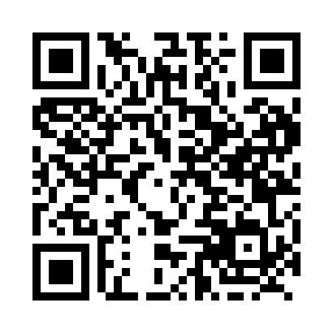
Prayer times for Caraquet, New Brunswick, Canada
Wed 1 May 2024 - Fri 31 May 2024
High Latitude Method: Angle Based Rule
Prayer Calculation Method: Islamic Society of North America
Asar Calculation Method: Hanafi

Date | Day | Fajr | Sunrise | Dhuhr | Asr | Maghrib | Isha
1 | Wed | 4:19 | 6:01 | 1:17 | 6:20 | 8:33 | 10:16
2 | Thu | 4:17 | 6:00 | 1:17 | 6:21 | 8:34 | 10:18
3 | Fri | 4:15 | 5:58 | 1:17 | 6:22 | 8:36 | 10:20
4 | Sat | 4:12 | 5:57 | 1:17 | 6:23 | 8:37 | 10:22
5 | Sun | 4:10 | 5:55 | 1:16 | 6:24 | 8:39 | 10:24
6 | Mon | 4:08 | 5:54 | 1:16 | 6:24 | 8:40 | 10:26
7 | Tue | 4:06 | 5:52 | 1:16 | 6:25 | 8:41 | 10:28
8 | Wed | 4:03 | 5:51 | 1:16 | 6:26 | 8:43 | 10:30
9 | Thu | 4:01 | 5:49 | 1:16 | 6:27 | 8:44 | 10:32
10 | Fri | 3:59 | 5:48 | 1:16 | 6:28 | 8:45 | 10:34
11 | Sat | 3:57 | 5:46 | 1:16 | 6:28 | 8:47 | 10:37
12 | Sun | 3:55 | 5:45 | 1:16 | 6:29 | 8:48 | 10:39
13 | Mon | 3:53 | 5:44 | 1:16 | 6:30 | 8:49 | 10:41
14 | Tue | 3:51 | 5:42 | 1:16 | 6:31 | 8:51 | 10:43
15 | Wed | 3:49 | 5:41 | 1:16 | 6:31 | 8:52 | 10:45
16 | Thu | 3:46 | 5:40 | 1:16 | 6:32 | 8:53 | 10:47
17 | Fri | 3:44 | 5:39 | 1:16 | 6:33 | 8:54 | 10:49
18 | Sat | 3:42 | 5:38 | 1:16 | 6:34 | 8:56 | 10:51
19 | Sun | 3:41 | 5:36 | 1:16 | 6:34 | 8:57 | 10:53
20 | Mon | 3:39 | 5:35 | 1:16 | 6:35 | 8:58 | 10:55
21 | Tue | 3:37 | 5:34 | 1:16 | 6:36 | 8:59 | 10:57
22 | Wed | 3:35 | 5:33 | 1:17 | 6:36 | 9:00 | 10:59
23 | Thu | 3:33 | 5:32 | 1:17 | 6:37 | 9:01 | 11:01
24 | Fri | 3:31 | 5:31 | 1:17 | 6:38 | 9:03 | 11:03
25 | Sat | 3:30 | 5:30 | 1:17 | 6:39 | 9:04 | 11:05
26 | Sun | 3:28 | 5:30 | 1:17 | 6:39 | 9:05 | 11:07
27 | Mon | 3:26 | 5:29 | 1:17 | 6:40 | 9:06 | 11:09
28 | Tue | 3:25 | 5:28 | 1:17 | 6:40 | 9:07 | 11:11
29 | Wed | 3:23 | 5:27 | 1:17 | 6:41 | 9:08 | 11:13
30 | Thu | 3:22 | 5:26 | 1:17 | 6:42 | 9:09 | 11:13
31 | Fri | 3:22 | 5:26 | 1:18 | 6:42 | 9:10 | 11:14
Prayer times provided by https://www.salahtimes.com

