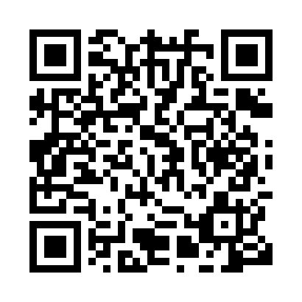
Prayer times for Beri, Cameroon
Wed 1 May 2024 - Fri 31 May 2024
High Latitude Method: None
Prayer Calculation Method: Muslim World League
Asar Calculation Method: Shafi

Date | Day | Fajr | Sunrise | Dhuhr | Asr | Maghrib | Isha
1 | Wed | 4:36 | 5:49 | 12:03 | 3:18 | 6:17 | 7:26
2 | Thu | 4:36 | 5:49 | 12:03 | 3:18 | 6:17 | 7:26
3 | Fri | 4:36 | 5:49 | 12:03 | 3:19 | 6:17 | 7:26
4 | Sat | 4:35 | 5:48 | 12:03 | 3:19 | 6:17 | 7:26
5 | Sun | 4:35 | 5:48 | 12:03 | 3:20 | 6:18 | 7:27
6 | Mon | 4:34 | 5:48 | 12:03 | 3:20 | 6:18 | 7:27
7 | Tue | 4:34 | 5:48 | 12:03 | 3:20 | 6:18 | 7:27
8 | Wed | 4:33 | 5:47 | 12:03 | 3:21 | 6:18 | 7:28
9 | Thu | 4:33 | 5:47 | 12:03 | 3:21 | 6:18 | 7:28
10 | Fri | 4:33 | 5:47 | 12:02 | 3:22 | 6:18 | 7:28
11 | Sat | 4:32 | 5:47 | 12:02 | 3:22 | 6:18 | 7:28
12 | Sun | 4:32 | 5:46 | 12:02 | 3:22 | 6:19 | 7:29
13 | Mon | 4:32 | 5:46 | 12:02 | 3:23 | 6:19 | 7:29
14 | Tue | 4:31 | 5:46 | 12:02 | 3:23 | 6:19 | 7:29
15 | Wed | 4:31 | 5:46 | 12:02 | 3:23 | 6:19 | 7:30
16 | Thu | 4:31 | 5:46 | 12:02 | 3:24 | 6:19 | 7:30
17 | Fri | 4:31 | 5:46 | 12:03 | 3:24 | 6:20 | 7:30
18 | Sat | 4:30 | 5:45 | 12:03 | 3:25 | 6:20 | 7:31
19 | Sun | 4:30 | 5:45 | 12:03 | 3:25 | 6:20 | 7:31
20 | Mon | 4:30 | 5:45 | 12:03 | 3:25 | 6:20 | 7:31
21 | Tue | 4:30 | 5:45 | 12:03 | 3:26 | 6:20 | 7:31
22 | Wed | 4:29 | 5:45 | 12:03 | 3:26 | 6:21 | 7:32
23 | Thu | 4:29 | 5:45 | 12:03 | 3:26 | 6:21 | 7:32
24 | Fri | 4:29 | 5:45 | 12:03 | 3:27 | 6:21 | 7:33
25 | Sat | 4:29 | 5:45 | 12:03 | 3:27 | 6:21 | 7:33
26 | Sun | 4:29 | 5:45 | 12:03 | 3:27 | 6:22 | 7:33
27 | Mon | 4:29 | 5:45 | 12:03 | 3:28 | 6:22 | 7:34
28 | Tue | 4:29 | 5:45 | 12:03 | 3:28 | 6:22 | 7:34
29 | Wed | 4:28 | 5:45 | 12:04 | 3:29 | 6:22 | 7:34
30 | Thu | 4:28 | 5:45 | 12:04 | 3:29 | 6:23 | 7:35
31 | Fri | 4:28 | 5:45 | 12:04 | 3:29 | 6:23 | 7:35
Prayer times provided by https://www.salahtimes.com

