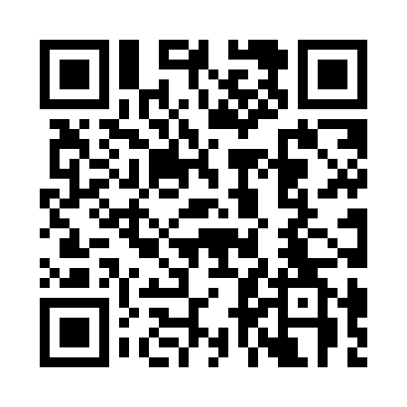
Prayer times for Val-Paradis, Quebec, Canada
Wed 1 May 2024 - Fri 31 May 2024
High Latitude Method: Angle Based Rule
Prayer Calculation Method: Islamic Society of North America
Asar Calculation Method: Hanafi

Date | Day | Fajr | Sunrise | Dhuhr | Asr | Maghrib | Isha
1 | Wed | 4:08 | 5:55 | 1:14 | 6:19 | 8:34 | 10:22
2 | Thu | 4:05 | 5:53 | 1:14 | 6:20 | 8:36 | 10:24
3 | Fri | 4:03 | 5:51 | 1:14 | 6:21 | 8:37 | 10:26
4 | Sat | 4:00 | 5:50 | 1:14 | 6:22 | 8:39 | 10:29
5 | Sun | 3:58 | 5:48 | 1:14 | 6:23 | 8:40 | 10:31
6 | Mon | 3:55 | 5:47 | 1:14 | 6:24 | 8:42 | 10:33
7 | Tue | 3:53 | 5:45 | 1:14 | 6:24 | 8:43 | 10:36
8 | Wed | 3:51 | 5:43 | 1:14 | 6:25 | 8:45 | 10:38
9 | Thu | 3:48 | 5:42 | 1:14 | 6:26 | 8:46 | 10:40
10 | Fri | 3:46 | 5:40 | 1:14 | 6:27 | 8:47 | 10:43
11 | Sat | 3:43 | 5:39 | 1:14 | 6:28 | 8:49 | 10:45
12 | Sun | 3:41 | 5:38 | 1:13 | 6:29 | 8:50 | 10:47
13 | Mon | 3:39 | 5:36 | 1:13 | 6:29 | 8:52 | 10:50
14 | Tue | 3:36 | 5:35 | 1:13 | 6:30 | 8:53 | 10:52
15 | Wed | 3:34 | 5:33 | 1:14 | 6:31 | 8:54 | 10:54
16 | Thu | 3:32 | 5:32 | 1:14 | 6:32 | 8:56 | 10:57
17 | Fri | 3:29 | 5:31 | 1:14 | 6:33 | 8:57 | 10:59
18 | Sat | 3:27 | 5:30 | 1:14 | 6:33 | 8:58 | 11:01
19 | Sun | 3:25 | 5:28 | 1:14 | 6:34 | 9:00 | 11:04
20 | Mon | 3:23 | 5:27 | 1:14 | 6:35 | 9:01 | 11:06
21 | Tue | 3:21 | 5:26 | 1:14 | 6:36 | 9:02 | 11:08
22 | Wed | 3:20 | 5:25 | 1:14 | 6:36 | 9:03 | 11:09
23 | Thu | 3:19 | 5:24 | 1:14 | 6:37 | 9:04 | 11:09
24 | Fri | 3:19 | 5:23 | 1:14 | 6:38 | 9:06 | 11:10
25 | Sat | 3:18 | 5:22 | 1:14 | 6:39 | 9:07 | 11:11
26 | Sun | 3:18 | 5:21 | 1:14 | 6:39 | 9:08 | 11:11
27 | Mon | 3:17 | 5:20 | 1:14 | 6:40 | 9:09 | 11:12
28 | Tue | 3:17 | 5:19 | 1:15 | 6:41 | 9:10 | 11:12
29 | Wed | 3:17 | 5:19 | 1:15 | 6:41 | 9:11 | 11:13
30 | Thu | 3:16 | 5:18 | 1:15 | 6:42 | 9:12 | 11:14
31 | Fri | 3:16 | 5:17 | 1:15 | 6:42 | 9:13 | 11:14
Prayer times provided by https://www.salahtimes.com

