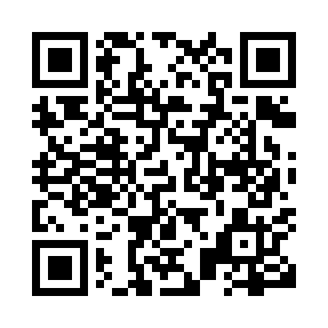
Prayer times for Uno, Manitoba, Canada
Wed 1 May 2024 - Fri 31 May 2024
High Latitude Method: Angle Based Rule
Prayer Calculation Method: Islamic Society of North America
Asar Calculation Method: Hanafi

Date | Day | Fajr | Sunrise | Dhuhr | Asr | Maghrib | Isha
1 | Wed | 4:28 | 6:19 | 1:41 | 6:48 | 9:05 | 10:57
2 | Thu | 4:25 | 6:17 | 1:41 | 6:49 | 9:06 | 10:59
3 | Fri | 4:22 | 6:15 | 1:41 | 6:50 | 9:08 | 11:02
4 | Sat | 4:20 | 6:14 | 1:41 | 6:50 | 9:10 | 11:04
5 | Sun | 4:17 | 6:12 | 1:41 | 6:51 | 9:11 | 11:07
6 | Mon | 4:14 | 6:10 | 1:41 | 6:52 | 9:13 | 11:09
7 | Tue | 4:12 | 6:09 | 1:41 | 6:53 | 9:14 | 11:12
8 | Wed | 4:09 | 6:07 | 1:41 | 6:54 | 9:16 | 11:14
9 | Thu | 4:07 | 6:05 | 1:41 | 6:55 | 9:17 | 11:17
10 | Fri | 4:04 | 6:04 | 1:41 | 6:56 | 9:19 | 11:19
11 | Sat | 4:01 | 6:02 | 1:41 | 6:57 | 9:20 | 11:22
12 | Sun | 3:59 | 6:01 | 1:41 | 6:58 | 9:21 | 11:24
13 | Mon | 3:56 | 5:59 | 1:41 | 6:58 | 9:23 | 11:27
14 | Tue | 3:54 | 5:58 | 1:41 | 6:59 | 9:24 | 11:29
15 | Wed | 3:51 | 5:57 | 1:41 | 7:00 | 9:26 | 11:32
16 | Thu | 3:48 | 5:55 | 1:41 | 7:01 | 9:27 | 11:34
17 | Fri | 3:48 | 5:54 | 1:41 | 7:02 | 9:29 | 11:35
18 | Sat | 3:47 | 5:53 | 1:41 | 7:03 | 9:30 | 11:36
19 | Sun | 3:46 | 5:51 | 1:41 | 7:03 | 9:31 | 11:36
20 | Mon | 3:46 | 5:50 | 1:41 | 7:04 | 9:33 | 11:37
21 | Tue | 3:45 | 5:49 | 1:41 | 7:05 | 9:34 | 11:38
22 | Wed | 3:45 | 5:48 | 1:41 | 7:06 | 9:35 | 11:38
23 | Thu | 3:44 | 5:47 | 1:41 | 7:06 | 9:36 | 11:39
24 | Fri | 3:44 | 5:46 | 1:41 | 7:07 | 9:38 | 11:40
25 | Sat | 3:43 | 5:45 | 1:41 | 7:08 | 9:39 | 11:40
26 | Sun | 3:43 | 5:44 | 1:42 | 7:09 | 9:40 | 11:41
27 | Mon | 3:42 | 5:43 | 1:42 | 7:09 | 9:41 | 11:42
28 | Tue | 3:42 | 5:42 | 1:42 | 7:10 | 9:42 | 11:42
29 | Wed | 3:42 | 5:41 | 1:42 | 7:11 | 9:43 | 11:43
30 | Thu | 3:41 | 5:40 | 1:42 | 7:11 | 9:45 | 11:43
31 | Fri | 3:41 | 5:39 | 1:42 | 7:12 | 9:46 | 11:44
Prayer times provided by https://www.salahtimes.com

