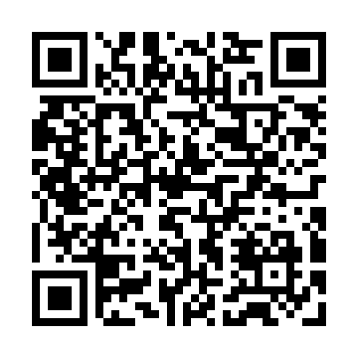
Prayer times for Bibra Lake, Australia
Mon 1 Apr 2024 - Tue 30 Apr 2024
High Latitude Method: None
Prayer Calculation Method: Muslim World League
Asar Calculation Method: Shafi

Date | Day | Fajr | Sunrise | Dhuhr | Asr | Maghrib | Isha
1 | Mon | 5:07 | 6:28 | 12:21 | 3:41 | 6:12 | 7:29
2 | Tue | 5:08 | 6:29 | 12:20 | 3:41 | 6:11 | 7:27
3 | Wed | 5:08 | 6:30 | 12:20 | 3:40 | 6:10 | 7:26
4 | Thu | 5:09 | 6:30 | 12:20 | 3:39 | 6:09 | 7:25
5 | Fri | 5:10 | 6:31 | 12:19 | 3:38 | 6:07 | 7:24
6 | Sat | 5:10 | 6:32 | 12:19 | 3:37 | 6:06 | 7:23
7 | Sun | 5:11 | 6:32 | 12:19 | 3:36 | 6:05 | 7:21
8 | Mon | 5:12 | 6:33 | 12:19 | 3:35 | 6:04 | 7:20
9 | Tue | 5:12 | 6:34 | 12:18 | 3:34 | 6:02 | 7:19
10 | Wed | 5:13 | 6:34 | 12:18 | 3:34 | 6:01 | 7:18
11 | Thu | 5:14 | 6:35 | 12:18 | 3:33 | 6:00 | 7:17
12 | Fri | 5:14 | 6:36 | 12:17 | 3:32 | 5:59 | 7:15
13 | Sat | 5:15 | 6:36 | 12:17 | 3:31 | 5:58 | 7:14
14 | Sun | 5:16 | 6:37 | 12:17 | 3:30 | 5:56 | 7:13
15 | Mon | 5:16 | 6:38 | 12:17 | 3:29 | 5:55 | 7:12
16 | Tue | 5:17 | 6:38 | 12:17 | 3:28 | 5:54 | 7:11
17 | Wed | 5:17 | 6:39 | 12:16 | 3:27 | 5:53 | 7:10
18 | Thu | 5:18 | 6:40 | 12:16 | 3:27 | 5:52 | 7:09
19 | Fri | 5:19 | 6:40 | 12:16 | 3:26 | 5:51 | 7:08
20 | Sat | 5:19 | 6:41 | 12:16 | 3:25 | 5:50 | 7:07
21 | Sun | 5:20 | 6:42 | 12:15 | 3:24 | 5:49 | 7:06
22 | Mon | 5:20 | 6:43 | 12:15 | 3:23 | 5:47 | 7:05
23 | Tue | 5:21 | 6:43 | 12:15 | 3:22 | 5:46 | 7:04
24 | Wed | 5:22 | 6:44 | 12:15 | 3:22 | 5:45 | 7:03
25 | Thu | 5:22 | 6:45 | 12:15 | 3:21 | 5:44 | 7:02
26 | Fri | 5:23 | 6:45 | 12:15 | 3:20 | 5:43 | 7:01
27 | Sat | 5:23 | 6:46 | 12:14 | 3:19 | 5:42 | 7:00
28 | Sun | 5:24 | 6:47 | 12:14 | 3:18 | 5:41 | 6:59
29 | Mon | 5:25 | 6:47 | 12:14 | 3:18 | 5:40 | 6:58
30 | Tue | 5:25 | 6:48 | 12:14 | 3:17 | 5:39 | 6:58
Prayer times provided by https://www.salahtimes.com

