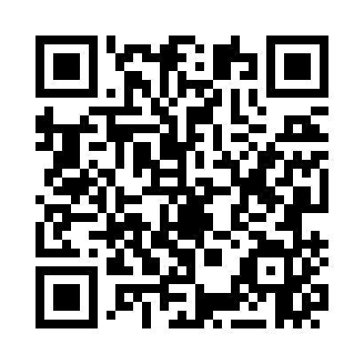
Prayer times for Cobram, Australia
Wed 1 May 2024 - Fri 31 May 2024
High Latitude Method: None
Prayer Calculation Method: Muslim World League
Asar Calculation Method: Shafi

Date | Day | Fajr | Sunrise | Dhuhr | Asr | Maghrib | Isha
1 | Wed | 5:29 | 6:55 | 12:15 | 3:11 | 5:33 | 6:55
2 | Thu | 5:29 | 6:56 | 12:14 | 3:10 | 5:32 | 6:54
3 | Fri | 5:30 | 6:57 | 12:14 | 3:09 | 5:31 | 6:53
4 | Sat | 5:31 | 6:58 | 12:14 | 3:08 | 5:30 | 6:52
5 | Sun | 5:31 | 6:59 | 12:14 | 3:08 | 5:29 | 6:52
6 | Mon | 5:32 | 7:00 | 12:14 | 3:07 | 5:28 | 6:51
7 | Tue | 5:33 | 7:00 | 12:14 | 3:06 | 5:27 | 6:50
8 | Wed | 5:33 | 7:01 | 12:14 | 3:05 | 5:26 | 6:49
9 | Thu | 5:34 | 7:02 | 12:14 | 3:05 | 5:25 | 6:48
10 | Fri | 5:35 | 7:03 | 12:14 | 3:04 | 5:25 | 6:48
11 | Sat | 5:35 | 7:04 | 12:14 | 3:03 | 5:24 | 6:47
12 | Sun | 5:36 | 7:04 | 12:14 | 3:02 | 5:23 | 6:46
13 | Mon | 5:37 | 7:05 | 12:14 | 3:02 | 5:22 | 6:46
14 | Tue | 5:37 | 7:06 | 12:14 | 3:01 | 5:21 | 6:45
15 | Wed | 5:38 | 7:07 | 12:14 | 3:00 | 5:21 | 6:44
16 | Thu | 5:39 | 7:08 | 12:14 | 3:00 | 5:20 | 6:44
17 | Fri | 5:39 | 7:08 | 12:14 | 2:59 | 5:19 | 6:43
18 | Sat | 5:40 | 7:09 | 12:14 | 2:59 | 5:18 | 6:42
19 | Sun | 5:41 | 7:10 | 12:14 | 2:58 | 5:18 | 6:42
20 | Mon | 5:41 | 7:11 | 12:14 | 2:58 | 5:17 | 6:41
21 | Tue | 5:42 | 7:11 | 12:14 | 2:57 | 5:16 | 6:41
22 | Wed | 5:42 | 7:12 | 12:14 | 2:57 | 5:16 | 6:40
23 | Thu | 5:43 | 7:13 | 12:14 | 2:56 | 5:15 | 6:40
24 | Fri | 5:44 | 7:14 | 12:14 | 2:56 | 5:15 | 6:40
25 | Sat | 5:44 | 7:14 | 12:14 | 2:55 | 5:14 | 6:39
26 | Sun | 5:45 | 7:15 | 12:15 | 2:55 | 5:14 | 6:39
27 | Mon | 5:45 | 7:16 | 12:15 | 2:55 | 5:13 | 6:39
28 | Tue | 5:46 | 7:16 | 12:15 | 2:54 | 5:13 | 6:38
29 | Wed | 5:47 | 7:17 | 12:15 | 2:54 | 5:12 | 6:38
30 | Thu | 5:47 | 7:18 | 12:15 | 2:54 | 5:12 | 6:38
31 | Fri | 5:48 | 7:18 | 12:15 | 2:53 | 5:12 | 6:37
Prayer times provided by https://www.salahtimes.com

