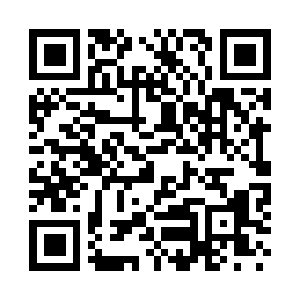
Prayer times for Navoiy, Uzbekistan
Wed 1 May 2024 - Fri 31 May 2024
High Latitude Method: None
Prayer Calculation Method: Muslim World League
Asar Calculation Method: Shafi

Date | Day | Fajr | Sunrise | Dhuhr | Asr | Maghrib | Isha
1 | Wed | 3:54 | 5:38 | 12:36 | 4:26 | 7:34 | 9:11
2 | Thu | 3:53 | 5:37 | 12:35 | 4:26 | 7:35 | 9:12
3 | Fri | 3:51 | 5:36 | 12:35 | 4:27 | 7:36 | 9:14
4 | Sat | 3:49 | 5:35 | 12:35 | 4:27 | 7:37 | 9:15
5 | Sun | 3:48 | 5:33 | 12:35 | 4:27 | 7:38 | 9:17
6 | Mon | 3:46 | 5:32 | 12:35 | 4:28 | 7:39 | 9:18
7 | Tue | 3:44 | 5:31 | 12:35 | 4:28 | 7:40 | 9:20
8 | Wed | 3:43 | 5:30 | 12:35 | 4:28 | 7:41 | 9:21
9 | Thu | 3:41 | 5:29 | 12:35 | 4:28 | 7:42 | 9:22
10 | Fri | 3:40 | 5:28 | 12:35 | 4:29 | 7:43 | 9:24
11 | Sat | 3:38 | 5:27 | 12:35 | 4:29 | 7:44 | 9:25
12 | Sun | 3:37 | 5:26 | 12:35 | 4:29 | 7:45 | 9:27
13 | Mon | 3:35 | 5:25 | 12:35 | 4:29 | 7:45 | 9:28
14 | Tue | 3:34 | 5:24 | 12:35 | 4:30 | 7:46 | 9:30
15 | Wed | 3:32 | 5:23 | 12:35 | 4:30 | 7:47 | 9:31
16 | Thu | 3:31 | 5:22 | 12:35 | 4:30 | 7:48 | 9:32
17 | Fri | 3:29 | 5:21 | 12:35 | 4:30 | 7:49 | 9:34
18 | Sat | 3:28 | 5:20 | 12:35 | 4:31 | 7:50 | 9:35
19 | Sun | 3:27 | 5:19 | 12:35 | 4:31 | 7:51 | 9:37
20 | Mon | 3:25 | 5:19 | 12:35 | 4:31 | 7:52 | 9:38
21 | Tue | 3:24 | 5:18 | 12:35 | 4:31 | 7:53 | 9:39
22 | Wed | 3:23 | 5:17 | 12:35 | 4:32 | 7:54 | 9:41
23 | Thu | 3:21 | 5:16 | 12:35 | 4:32 | 7:55 | 9:42
24 | Fri | 3:20 | 5:16 | 12:35 | 4:32 | 7:55 | 9:43
25 | Sat | 3:19 | 5:15 | 12:36 | 4:32 | 7:56 | 9:45
26 | Sun | 3:18 | 5:14 | 12:36 | 4:33 | 7:57 | 9:46
27 | Mon | 3:17 | 5:14 | 12:36 | 4:33 | 7:58 | 9:47
28 | Tue | 3:16 | 5:13 | 12:36 | 4:33 | 7:59 | 9:48
29 | Wed | 3:15 | 5:13 | 12:36 | 4:33 | 7:59 | 9:49
30 | Thu | 3:14 | 5:12 | 12:36 | 4:34 | 8:00 | 9:51
31 | Fri | 3:13 | 5:12 | 12:36 | 4:34 | 8:01 | 9:52
Prayer times provided by https://www.salahtimes.com

