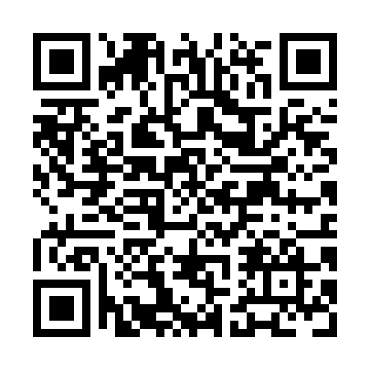
Prayer times for Escuminac Glenn, Quebec, Canada
Mon 1 Jul 2024 - Wed 31 Jul 2024
High Latitude Method: Angle Based Rule
Prayer Calculation Method: Islamic Society of North America
Asar Calculation Method: Hanafi

Date | Day | Fajr | Sunrise | Dhuhr | Asr | Maghrib | Isha
1 | Mon | 2:30 | 4:30 | 12:30 | 5:59 | 8:29 | 10:30
2 | Tue | 2:31 | 4:31 | 12:30 | 5:59 | 8:29 | 10:30
3 | Wed | 2:31 | 4:32 | 12:30 | 5:58 | 8:29 | 10:30
4 | Thu | 2:31 | 4:32 | 12:31 | 5:58 | 8:28 | 10:29
5 | Fri | 2:32 | 4:33 | 12:31 | 5:58 | 8:28 | 10:29
6 | Sat | 2:32 | 4:34 | 12:31 | 5:58 | 8:28 | 10:29
7 | Sun | 2:33 | 4:35 | 12:31 | 5:58 | 8:27 | 10:29
8 | Mon | 2:33 | 4:36 | 12:31 | 5:58 | 8:26 | 10:29
9 | Tue | 2:34 | 4:36 | 12:31 | 5:57 | 8:26 | 10:29
10 | Wed | 2:34 | 4:37 | 12:32 | 5:57 | 8:25 | 10:28
11 | Thu | 2:35 | 4:38 | 12:32 | 5:57 | 8:25 | 10:28
12 | Fri | 2:35 | 4:39 | 12:32 | 5:56 | 8:24 | 10:28
13 | Sat | 2:36 | 4:40 | 12:32 | 5:56 | 8:23 | 10:27
14 | Sun | 2:37 | 4:41 | 12:32 | 5:56 | 8:22 | 10:27
15 | Mon | 2:37 | 4:42 | 12:32 | 5:55 | 8:21 | 10:26
16 | Tue | 2:39 | 4:43 | 12:32 | 5:55 | 8:20 | 10:24
17 | Wed | 2:41 | 4:44 | 12:32 | 5:54 | 8:20 | 10:22
18 | Thu | 2:43 | 4:46 | 12:32 | 5:54 | 8:19 | 10:20
19 | Fri | 2:45 | 4:47 | 12:32 | 5:53 | 8:18 | 10:18
20 | Sat | 2:47 | 4:48 | 12:32 | 5:53 | 8:17 | 10:17
21 | Sun | 2:49 | 4:49 | 12:32 | 5:52 | 8:15 | 10:15
22 | Mon | 2:51 | 4:50 | 12:33 | 5:51 | 8:14 | 10:13
23 | Tue | 2:53 | 4:51 | 12:33 | 5:51 | 8:13 | 10:11
24 | Wed | 2:55 | 4:52 | 12:33 | 5:50 | 8:12 | 10:09
25 | Thu | 2:58 | 4:54 | 12:33 | 5:49 | 8:11 | 10:06
26 | Fri | 3:00 | 4:55 | 12:33 | 5:49 | 8:10 | 10:04
27 | Sat | 3:02 | 4:56 | 12:33 | 5:48 | 8:08 | 10:02
28 | Sun | 3:04 | 4:57 | 12:33 | 5:47 | 8:07 | 10:00
29 | Mon | 3:06 | 4:59 | 12:32 | 5:46 | 8:06 | 9:58
30 | Tue | 3:08 | 5:00 | 12:32 | 5:46 | 8:04 | 9:56
31 | Wed | 3:10 | 5:01 | 12:32 | 5:45 | 8:03 | 9:54
Prayer times provided by https://www.salahtimes.com

