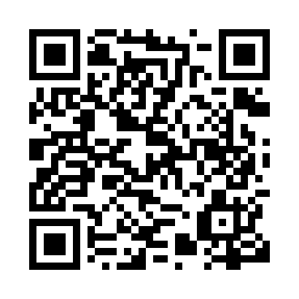
Prayer times for Keyano, Quebec, Canada
Mon 1 Jul 2024 - Wed 31 Jul 2024
High Latitude Method: Angle Based Rule
Prayer Calculation Method: Islamic Society of North America
Asar Calculation Method: Hanafi

Date | Day | Fajr | Sunrise | Dhuhr | Asr | Maghrib | Isha
1 | Mon | 2:43 | 4:28 | 12:58 | 6:40 | 9:28 | 11:13
2 | Tue | 2:44 | 4:29 | 12:58 | 6:40 | 9:27 | 11:13
3 | Wed | 2:44 | 4:30 | 12:59 | 6:39 | 9:27 | 11:13
4 | Thu | 2:45 | 4:31 | 12:59 | 6:39 | 9:26 | 11:12
5 | Fri | 2:45 | 4:32 | 12:59 | 6:39 | 9:26 | 11:12
6 | Sat | 2:46 | 4:33 | 12:59 | 6:39 | 9:25 | 11:12
7 | Sun | 2:46 | 4:34 | 12:59 | 6:38 | 9:24 | 11:12
8 | Mon | 2:47 | 4:35 | 12:59 | 6:38 | 9:24 | 11:11
9 | Tue | 2:48 | 4:36 | 12:59 | 6:38 | 9:23 | 11:11
10 | Wed | 2:48 | 4:37 | 1:00 | 6:37 | 9:22 | 11:11
11 | Thu | 2:49 | 4:38 | 1:00 | 6:37 | 9:21 | 11:10
12 | Fri | 2:50 | 4:39 | 1:00 | 6:36 | 9:20 | 11:10
13 | Sat | 2:50 | 4:41 | 1:00 | 6:36 | 9:19 | 11:09
14 | Sun | 2:51 | 4:42 | 1:00 | 6:35 | 9:18 | 11:09
15 | Mon | 2:52 | 4:43 | 1:00 | 6:35 | 9:17 | 11:08
16 | Tue | 2:52 | 4:45 | 1:00 | 6:34 | 9:15 | 11:08
17 | Wed | 2:53 | 4:46 | 1:00 | 6:34 | 9:14 | 11:07
18 | Thu | 2:54 | 4:47 | 1:00 | 6:33 | 9:13 | 11:06
19 | Fri | 2:55 | 4:49 | 1:01 | 6:32 | 9:11 | 11:06
20 | Sat | 2:55 | 4:50 | 1:01 | 6:32 | 9:10 | 11:05
21 | Sun | 2:56 | 4:52 | 1:01 | 6:31 | 9:09 | 11:04
22 | Mon | 2:57 | 4:53 | 1:01 | 6:30 | 9:07 | 11:04
23 | Tue | 2:58 | 4:55 | 1:01 | 6:29 | 9:06 | 11:03
24 | Wed | 2:58 | 4:56 | 1:01 | 6:28 | 9:04 | 11:02
25 | Thu | 2:59 | 4:58 | 1:01 | 6:27 | 9:03 | 11:01
26 | Fri | 3:00 | 5:00 | 1:01 | 6:26 | 9:01 | 11:01
27 | Sat | 3:01 | 5:01 | 1:01 | 6:26 | 8:59 | 11:00
28 | Sun | 3:02 | 5:03 | 1:01 | 6:25 | 8:58 | 10:59
29 | Mon | 3:02 | 5:04 | 1:01 | 6:23 | 8:56 | 10:58
30 | Tue | 3:03 | 5:06 | 1:01 | 6:22 | 8:54 | 10:57
31 | Wed | 3:04 | 5:08 | 1:01 | 6:21 | 8:52 | 10:56
Prayer times provided by https://www.salahtimes.com

