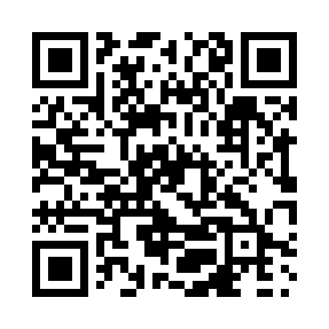
Prayer times for Battrum, Saskatchewan, Canada
Mon 1 Apr 2024 - Tue 30 Apr 2024
High Latitude Method: Angle Based Rule
Prayer Calculation Method: Islamic Society of North America
Asar Calculation Method: Hanafi

Date | Day | Fajr | Sunrise | Dhuhr | Asr | Maghrib | Isha
1 | Mon | 5:14 | 6:48 | 1:17 | 5:45 | 7:47 | 9:21
2 | Tue | 5:11 | 6:46 | 1:17 | 5:46 | 7:48 | 9:23
3 | Wed | 5:09 | 6:44 | 1:16 | 5:47 | 7:50 | 9:25
4 | Thu | 5:06 | 6:41 | 1:16 | 5:48 | 7:52 | 9:27
5 | Fri | 5:04 | 6:39 | 1:16 | 5:50 | 7:53 | 9:29
6 | Sat | 5:01 | 6:37 | 1:16 | 5:51 | 7:55 | 9:31
7 | Sun | 4:58 | 6:35 | 1:15 | 5:52 | 7:57 | 9:33
8 | Mon | 4:56 | 6:33 | 1:15 | 5:53 | 7:58 | 9:35
9 | Tue | 4:53 | 6:31 | 1:15 | 5:54 | 8:00 | 9:37
10 | Wed | 4:51 | 6:28 | 1:14 | 5:55 | 8:01 | 9:40
11 | Thu | 4:48 | 6:26 | 1:14 | 5:56 | 8:03 | 9:42
12 | Fri | 4:45 | 6:24 | 1:14 | 5:57 | 8:05 | 9:44
13 | Sat | 4:43 | 6:22 | 1:14 | 5:58 | 8:06 | 9:46
14 | Sun | 4:40 | 6:20 | 1:13 | 6:00 | 8:08 | 9:48
15 | Mon | 4:37 | 6:18 | 1:13 | 6:01 | 8:09 | 9:50
16 | Tue | 4:35 | 6:16 | 1:13 | 6:02 | 8:11 | 9:53
17 | Wed | 4:32 | 6:14 | 1:13 | 6:03 | 8:13 | 9:55
18 | Thu | 4:29 | 6:12 | 1:13 | 6:04 | 8:14 | 9:57
19 | Fri | 4:27 | 6:10 | 1:12 | 6:05 | 8:16 | 9:59
20 | Sat | 4:24 | 6:08 | 1:12 | 6:06 | 8:17 | 10:02
21 | Sun | 4:21 | 6:06 | 1:12 | 6:07 | 8:19 | 10:04
22 | Mon | 4:19 | 6:04 | 1:12 | 6:08 | 8:21 | 10:06
23 | Tue | 4:16 | 6:02 | 1:12 | 6:09 | 8:22 | 10:09
24 | Wed | 4:13 | 6:00 | 1:11 | 6:10 | 8:24 | 10:11
25 | Thu | 4:10 | 5:58 | 1:11 | 6:11 | 8:25 | 10:13
26 | Fri | 4:08 | 5:56 | 1:11 | 6:12 | 8:27 | 10:16
27 | Sat | 4:05 | 5:54 | 1:11 | 6:13 | 8:28 | 10:18
28 | Sun | 4:02 | 5:52 | 1:11 | 6:14 | 8:30 | 10:20
29 | Mon | 4:00 | 5:50 | 1:11 | 6:15 | 8:32 | 10:23
30 | Tue | 3:57 | 5:49 | 1:10 | 6:16 | 8:33 | 10:25
Prayer times provided by https://www.salahtimes.com

