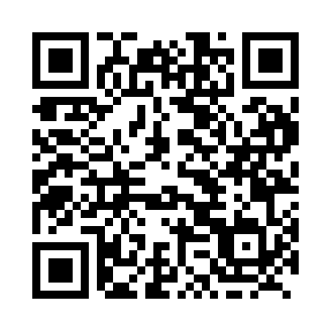
Prayer times for Traders Cove, British Columbia, Canada
Wed 1 May 2024 - Fri 31 May 2024
High Latitude Method: Angle Based Rule
Prayer Calculation Method: Islamic Society of North America
Asar Calculation Method: Hanafi

Date | Day | Fajr | Sunrise | Dhuhr | Asr | Maghrib | Isha
1 | Wed | 3:43 | 5:33 | 12:55 | 6:01 | 8:18 | 10:08
2 | Thu | 3:41 | 5:31 | 12:55 | 6:02 | 8:19 | 10:11
3 | Fri | 3:38 | 5:30 | 12:55 | 6:03 | 8:21 | 10:13
4 | Sat | 3:35 | 5:28 | 12:55 | 6:04 | 8:22 | 10:15
5 | Sun | 3:33 | 5:26 | 12:55 | 6:05 | 8:24 | 10:18
6 | Mon | 3:30 | 5:25 | 12:55 | 6:05 | 8:25 | 10:20
7 | Tue | 3:28 | 5:23 | 12:55 | 6:06 | 8:27 | 10:23
8 | Wed | 3:25 | 5:22 | 12:54 | 6:07 | 8:28 | 10:25
9 | Thu | 3:23 | 5:20 | 12:54 | 6:08 | 8:30 | 10:28
10 | Fri | 3:20 | 5:18 | 12:54 | 6:09 | 8:31 | 10:30
11 | Sat | 3:17 | 5:17 | 12:54 | 6:10 | 8:33 | 10:33
12 | Sun | 3:15 | 5:15 | 12:54 | 6:11 | 8:34 | 10:35
13 | Mon | 3:12 | 5:14 | 12:54 | 6:12 | 8:35 | 10:38
14 | Tue | 3:10 | 5:13 | 12:54 | 6:12 | 8:37 | 10:40
15 | Wed | 3:07 | 5:11 | 12:54 | 6:13 | 8:38 | 10:43
16 | Thu | 3:05 | 5:10 | 12:54 | 6:14 | 8:40 | 10:45
17 | Fri | 3:03 | 5:09 | 12:54 | 6:15 | 8:41 | 10:48
18 | Sat | 3:01 | 5:07 | 12:54 | 6:16 | 8:42 | 10:49
19 | Sun | 3:00 | 5:06 | 12:55 | 6:16 | 8:44 | 10:49
20 | Mon | 3:00 | 5:05 | 12:55 | 6:17 | 8:45 | 10:50
21 | Tue | 2:59 | 5:04 | 12:55 | 6:18 | 8:46 | 10:51
22 | Wed | 2:59 | 5:03 | 12:55 | 6:19 | 8:47 | 10:51
23 | Thu | 2:58 | 5:02 | 12:55 | 6:19 | 8:49 | 10:52
24 | Fri | 2:58 | 5:00 | 12:55 | 6:20 | 8:50 | 10:53
25 | Sat | 2:57 | 4:59 | 12:55 | 6:21 | 8:51 | 10:53
26 | Sun | 2:57 | 4:59 | 12:55 | 6:22 | 8:52 | 10:54
27 | Mon | 2:57 | 4:58 | 12:55 | 6:22 | 8:53 | 10:54
28 | Tue | 2:56 | 4:57 | 12:55 | 6:23 | 8:55 | 10:55
29 | Wed | 2:56 | 4:56 | 12:56 | 6:24 | 8:56 | 10:56
30 | Thu | 2:55 | 4:55 | 12:56 | 6:24 | 8:57 | 10:56
31 | Fri | 2:55 | 4:54 | 12:56 | 6:25 | 8:58 | 10:57
Prayer times provided by https://www.salahtimes.com

