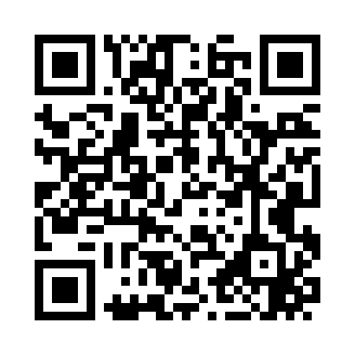
Prayer times for Avis, New Mexico, USA
Mon 1 Jul 2024 - Wed 31 Jul 2024
High Latitude Method: Angle Based Rule
Prayer Calculation Method: Islamic Society of North America
Asar Calculation Method: Shafi

Date | Day | Fajr | Sunrise | Dhuhr | Asr | Maghrib | Isha
1 | Mon | 4:36 | 5:58 | 1:06 | 4:48 | 8:14 | 9:35
2 | Tue | 4:37 | 5:58 | 1:06 | 4:48 | 8:14 | 9:35
3 | Wed | 4:37 | 5:59 | 1:06 | 4:48 | 8:14 | 9:35
4 | Thu | 4:38 | 5:59 | 1:06 | 4:49 | 8:13 | 9:35
5 | Fri | 4:38 | 6:00 | 1:07 | 4:49 | 8:13 | 9:34
6 | Sat | 4:39 | 6:00 | 1:07 | 4:49 | 8:13 | 9:34
7 | Sun | 4:40 | 6:01 | 1:07 | 4:49 | 8:13 | 9:34
8 | Mon | 4:40 | 6:01 | 1:07 | 4:49 | 8:13 | 9:33
9 | Tue | 4:41 | 6:02 | 1:07 | 4:49 | 8:12 | 9:33
10 | Wed | 4:42 | 6:02 | 1:07 | 4:50 | 8:12 | 9:33
11 | Thu | 4:43 | 6:03 | 1:07 | 4:50 | 8:12 | 9:32
12 | Fri | 4:43 | 6:03 | 1:08 | 4:50 | 8:11 | 9:32
13 | Sat | 4:44 | 6:04 | 1:08 | 4:50 | 8:11 | 9:31
14 | Sun | 4:45 | 6:05 | 1:08 | 4:50 | 8:11 | 9:30
15 | Mon | 4:46 | 6:05 | 1:08 | 4:50 | 8:10 | 9:30
16 | Tue | 4:46 | 6:06 | 1:08 | 4:50 | 8:10 | 9:29
17 | Wed | 4:47 | 6:06 | 1:08 | 4:50 | 8:09 | 9:29
18 | Thu | 4:48 | 6:07 | 1:08 | 4:50 | 8:09 | 9:28
19 | Fri | 4:49 | 6:08 | 1:08 | 4:50 | 8:08 | 9:27
20 | Sat | 4:50 | 6:08 | 1:08 | 4:50 | 8:08 | 9:26
21 | Sun | 4:51 | 6:09 | 1:08 | 4:50 | 8:07 | 9:26
22 | Mon | 4:51 | 6:10 | 1:08 | 4:50 | 8:07 | 9:25
23 | Tue | 4:52 | 6:10 | 1:08 | 4:50 | 8:06 | 9:24
24 | Wed | 4:53 | 6:11 | 1:08 | 4:50 | 8:05 | 9:23
25 | Thu | 4:54 | 6:12 | 1:08 | 4:50 | 8:05 | 9:22
26 | Fri | 4:55 | 6:12 | 1:08 | 4:50 | 8:04 | 9:21
27 | Sat | 4:56 | 6:13 | 1:08 | 4:50 | 8:03 | 9:20
28 | Sun | 4:57 | 6:14 | 1:08 | 4:50 | 8:03 | 9:19
29 | Mon | 4:58 | 6:14 | 1:08 | 4:50 | 8:02 | 9:18
30 | Tue | 4:58 | 6:15 | 1:08 | 4:50 | 8:01 | 9:17
31 | Wed | 4:59 | 6:16 | 1:08 | 4:50 | 8:00 | 9:16
Prayer times provided by https://www.salahtimes.com

