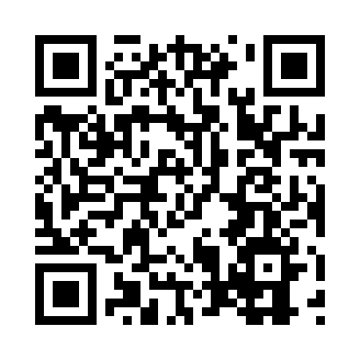
Prayer times for Nuevitas, Cuba
Wed 1 May 2024 - Fri 31 May 2024
High Latitude Method: None
Prayer Calculation Method: Muslim World League
Asar Calculation Method: Shafi

Date | Day | Fajr | Sunrise | Dhuhr | Asr | Maghrib | Isha
1 | Wed | 5:19 | 6:38 | 1:06 | 4:27 | 7:35 | 8:49
2 | Thu | 5:18 | 6:37 | 1:06 | 4:27 | 7:35 | 8:50
3 | Fri | 5:17 | 6:36 | 1:06 | 4:27 | 7:36 | 8:50
4 | Sat | 5:16 | 6:36 | 1:06 | 4:26 | 7:36 | 8:51
5 | Sun | 5:15 | 6:35 | 1:06 | 4:26 | 7:36 | 8:51
6 | Mon | 5:15 | 6:35 | 1:06 | 4:26 | 7:37 | 8:52
7 | Tue | 5:14 | 6:34 | 1:06 | 4:25 | 7:37 | 8:53
8 | Wed | 5:13 | 6:33 | 1:05 | 4:25 | 7:38 | 8:53
9 | Thu | 5:12 | 6:33 | 1:05 | 4:25 | 7:38 | 8:54
10 | Fri | 5:12 | 6:32 | 1:05 | 4:24 | 7:39 | 8:54
11 | Sat | 5:11 | 6:32 | 1:05 | 4:24 | 7:39 | 8:55
12 | Sun | 5:10 | 6:32 | 1:05 | 4:24 | 7:39 | 8:56
13 | Mon | 5:10 | 6:31 | 1:05 | 4:23 | 7:40 | 8:56
14 | Tue | 5:09 | 6:31 | 1:05 | 4:23 | 7:40 | 8:57
15 | Wed | 5:09 | 6:30 | 1:05 | 4:23 | 7:41 | 8:57
16 | Thu | 5:08 | 6:30 | 1:05 | 4:23 | 7:41 | 8:58
17 | Fri | 5:08 | 6:29 | 1:05 | 4:22 | 7:42 | 8:59
18 | Sat | 5:07 | 6:29 | 1:05 | 4:22 | 7:42 | 8:59
19 | Sun | 5:06 | 6:29 | 1:06 | 4:22 | 7:42 | 9:00
20 | Mon | 5:06 | 6:28 | 1:06 | 4:22 | 7:43 | 9:00
21 | Tue | 5:06 | 6:28 | 1:06 | 4:22 | 7:43 | 9:01
22 | Wed | 5:05 | 6:28 | 1:06 | 4:21 | 7:44 | 9:02
23 | Thu | 5:05 | 6:28 | 1:06 | 4:21 | 7:44 | 9:02
24 | Fri | 5:04 | 6:27 | 1:06 | 4:21 | 7:45 | 9:03
25 | Sat | 5:04 | 6:27 | 1:06 | 4:21 | 7:45 | 9:03
26 | Sun | 5:03 | 6:27 | 1:06 | 4:21 | 7:46 | 9:04
27 | Mon | 5:03 | 6:27 | 1:06 | 4:21 | 7:46 | 9:05
28 | Tue | 5:03 | 6:27 | 1:06 | 4:21 | 7:46 | 9:05
29 | Wed | 5:03 | 6:26 | 1:07 | 4:22 | 7:47 | 9:06
30 | Thu | 5:02 | 6:26 | 1:07 | 4:22 | 7:47 | 9:06
31 | Fri | 5:02 | 6:26 | 1:07 | 4:23 | 7:48 | 9:07
Prayer times provided by https://www.salahtimes.com

