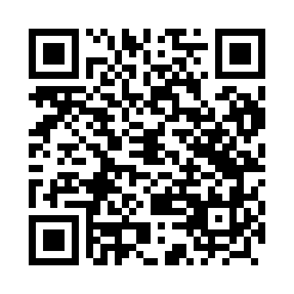
Prayer times for Noskowo, Poland
Wed 1 May 2024 - Fri 31 May 2024
High Latitude Method: Angle Based Rule
Prayer Calculation Method: Muslim World League
Asar Calculation Method: Hanafi

Date | Day | Fajr | Sunrise | Dhuhr | Asr | Maghrib | Isha
1 | Wed | 2:36 | 5:14 | 12:50 | 6:00 | 8:27 | 10:56
2 | Thu | 2:35 | 5:12 | 12:50 | 6:01 | 8:28 | 10:57
3 | Fri | 2:34 | 5:10 | 12:50 | 6:03 | 8:30 | 10:57
4 | Sat | 2:33 | 5:08 | 12:49 | 6:04 | 8:32 | 10:58
5 | Sun | 2:32 | 5:06 | 12:49 | 6:05 | 8:34 | 10:59
6 | Mon | 2:31 | 5:04 | 12:49 | 6:06 | 8:36 | 11:00
7 | Tue | 2:31 | 5:02 | 12:49 | 6:07 | 8:38 | 11:00
8 | Wed | 2:30 | 5:00 | 12:49 | 6:08 | 8:39 | 11:01
9 | Thu | 2:29 | 4:58 | 12:49 | 6:09 | 8:41 | 11:02
10 | Fri | 2:28 | 4:56 | 12:49 | 6:10 | 8:43 | 11:03
11 | Sat | 2:27 | 4:54 | 12:49 | 6:11 | 8:45 | 11:03
12 | Sun | 2:27 | 4:53 | 12:49 | 6:12 | 8:47 | 11:04
13 | Mon | 2:26 | 4:51 | 12:49 | 6:13 | 8:48 | 11:05
14 | Tue | 2:25 | 4:49 | 12:49 | 6:14 | 8:50 | 11:06
15 | Wed | 2:25 | 4:47 | 12:49 | 6:15 | 8:52 | 11:06
16 | Thu | 2:24 | 4:46 | 12:49 | 6:16 | 8:53 | 11:07
17 | Fri | 2:23 | 4:44 | 12:49 | 6:17 | 8:55 | 11:08
18 | Sat | 2:23 | 4:42 | 12:49 | 6:18 | 8:57 | 11:09
19 | Sun | 2:22 | 4:41 | 12:49 | 6:19 | 8:58 | 11:09
20 | Mon | 2:22 | 4:39 | 12:49 | 6:20 | 9:00 | 11:10
21 | Tue | 2:21 | 4:38 | 12:49 | 6:21 | 9:02 | 11:11
22 | Wed | 2:20 | 4:36 | 12:49 | 6:22 | 9:03 | 11:12
23 | Thu | 2:20 | 4:35 | 12:50 | 6:23 | 9:05 | 11:12
24 | Fri | 2:20 | 4:34 | 12:50 | 6:24 | 9:06 | 11:13
25 | Sat | 2:19 | 4:32 | 12:50 | 6:24 | 9:08 | 11:14
26 | Sun | 2:19 | 4:31 | 12:50 | 6:25 | 9:09 | 11:14
27 | Mon | 2:18 | 4:30 | 12:50 | 6:26 | 9:11 | 11:15
28 | Tue | 2:18 | 4:29 | 12:50 | 6:27 | 9:12 | 11:16
29 | Wed | 2:17 | 4:28 | 12:50 | 6:28 | 9:13 | 11:16
30 | Thu | 2:17 | 4:27 | 12:50 | 6:28 | 9:15 | 11:17
31 | Fri | 2:17 | 4:26 | 12:51 | 6:29 | 9:16 | 11:18
Prayer times provided by https://www.salahtimes.com

