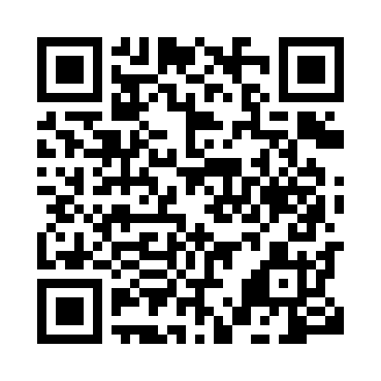
Prayer times for Bimba, Cameroon
Mon 1 Apr 2024 - Tue 30 Apr 2024
High Latitude Method: None
Prayer Calculation Method: Muslim World League
Asar Calculation Method: Shafi

Date | Day | Fajr | Sunrise | Dhuhr | Asr | Maghrib | Isha
1 | Mon | 4:53 | 6:03 | 12:07 | 3:09 | 6:12 | 7:17
2 | Tue | 4:53 | 6:02 | 12:07 | 3:10 | 6:12 | 7:17
3 | Wed | 4:53 | 6:02 | 12:07 | 3:10 | 6:12 | 7:17
4 | Thu | 4:52 | 6:01 | 12:06 | 3:11 | 6:11 | 7:17
5 | Fri | 4:52 | 6:01 | 12:06 | 3:11 | 6:11 | 7:17
6 | Sat | 4:51 | 6:01 | 12:06 | 3:11 | 6:11 | 7:17
7 | Sun | 4:51 | 6:00 | 12:06 | 3:12 | 6:11 | 7:16
8 | Mon | 4:50 | 6:00 | 12:05 | 3:12 | 6:11 | 7:16
9 | Tue | 4:50 | 5:59 | 12:05 | 3:13 | 6:11 | 7:16
10 | Wed | 4:49 | 5:59 | 12:05 | 3:13 | 6:10 | 7:16
11 | Thu | 4:49 | 5:59 | 12:04 | 3:13 | 6:10 | 7:16
12 | Fri | 4:48 | 5:58 | 12:04 | 3:14 | 6:10 | 7:16
13 | Sat | 4:48 | 5:58 | 12:04 | 3:14 | 6:10 | 7:16
14 | Sun | 4:48 | 5:58 | 12:04 | 3:15 | 6:10 | 7:16
15 | Mon | 4:47 | 5:57 | 12:03 | 3:15 | 6:10 | 7:16
16 | Tue | 4:47 | 5:57 | 12:03 | 3:15 | 6:10 | 7:16
17 | Wed | 4:46 | 5:57 | 12:03 | 3:16 | 6:10 | 7:16
18 | Thu | 4:46 | 5:56 | 12:03 | 3:16 | 6:09 | 7:16
19 | Fri | 4:45 | 5:56 | 12:03 | 3:16 | 6:09 | 7:16
20 | Sat | 4:45 | 5:56 | 12:02 | 3:16 | 6:09 | 7:16
21 | Sun | 4:45 | 5:55 | 12:02 | 3:17 | 6:09 | 7:16
22 | Mon | 4:44 | 5:55 | 12:02 | 3:17 | 6:09 | 7:16
23 | Tue | 4:44 | 5:55 | 12:02 | 3:17 | 6:09 | 7:16
24 | Wed | 4:43 | 5:54 | 12:02 | 3:18 | 6:09 | 7:16
25 | Thu | 4:43 | 5:54 | 12:01 | 3:18 | 6:09 | 7:16
26 | Fri | 4:43 | 5:54 | 12:01 | 3:18 | 6:09 | 7:16
27 | Sat | 4:42 | 5:54 | 12:01 | 3:18 | 6:09 | 7:16
28 | Sun | 4:42 | 5:53 | 12:01 | 3:19 | 6:09 | 7:16
29 | Mon | 4:42 | 5:53 | 12:01 | 3:19 | 6:09 | 7:16
30 | Tue | 4:41 | 5:53 | 12:01 | 3:19 | 6:09 | 7:16
Prayer times provided by https://www.salahtimes.com

