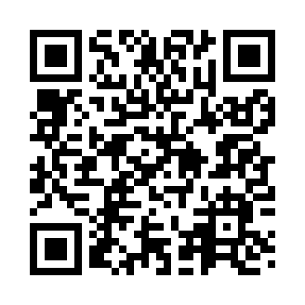
Prayer times for Millerama View, Utah, USA
Mon 1 Jul 2024 - Wed 31 Jul 2024
High Latitude Method: Angle Based Rule
Prayer Calculation Method: Islamic Society of North America
Asar Calculation Method: Shafi

Date | Day | Fajr | Sunrise | Dhuhr | Asr | Maghrib | Isha
1 | Mon | 4:22 | 6:01 | 1:32 | 5:32 | 9:03 | 10:41
2 | Tue | 4:23 | 6:01 | 1:32 | 5:32 | 9:03 | 10:41
3 | Wed | 4:24 | 6:02 | 1:32 | 5:32 | 9:02 | 10:41
4 | Thu | 4:24 | 6:03 | 1:32 | 5:32 | 9:02 | 10:40
5 | Fri | 4:25 | 6:03 | 1:33 | 5:32 | 9:02 | 10:40
6 | Sat | 4:26 | 6:04 | 1:33 | 5:32 | 9:02 | 10:39
7 | Sun | 4:27 | 6:04 | 1:33 | 5:32 | 9:01 | 10:38
8 | Mon | 4:28 | 6:05 | 1:33 | 5:32 | 9:01 | 10:38
9 | Tue | 4:29 | 6:06 | 1:33 | 5:32 | 9:00 | 10:37
10 | Wed | 4:30 | 6:06 | 1:33 | 5:32 | 9:00 | 10:36
11 | Thu | 4:31 | 6:07 | 1:34 | 5:32 | 9:00 | 10:36
12 | Fri | 4:32 | 6:08 | 1:34 | 5:32 | 8:59 | 10:35
13 | Sat | 4:33 | 6:09 | 1:34 | 5:32 | 8:58 | 10:34
14 | Sun | 4:34 | 6:09 | 1:34 | 5:32 | 8:58 | 10:33
15 | Mon | 4:35 | 6:10 | 1:34 | 5:32 | 8:57 | 10:32
16 | Tue | 4:36 | 6:11 | 1:34 | 5:32 | 8:57 | 10:31
17 | Wed | 4:38 | 6:12 | 1:34 | 5:32 | 8:56 | 10:30
18 | Thu | 4:39 | 6:13 | 1:34 | 5:32 | 8:55 | 10:29
19 | Fri | 4:40 | 6:14 | 1:34 | 5:32 | 8:55 | 10:28
20 | Sat | 4:41 | 6:14 | 1:34 | 5:32 | 8:54 | 10:27
21 | Sun | 4:42 | 6:15 | 1:34 | 5:32 | 8:53 | 10:26
22 | Mon | 4:44 | 6:16 | 1:34 | 5:31 | 8:52 | 10:24
23 | Tue | 4:45 | 6:17 | 1:34 | 5:31 | 8:51 | 10:23
24 | Wed | 4:46 | 6:18 | 1:34 | 5:31 | 8:50 | 10:22
25 | Thu | 4:47 | 6:19 | 1:34 | 5:31 | 8:50 | 10:21
26 | Fri | 4:49 | 6:20 | 1:34 | 5:30 | 8:49 | 10:19
27 | Sat | 4:50 | 6:21 | 1:34 | 5:30 | 8:48 | 10:18
28 | Sun | 4:51 | 6:22 | 1:34 | 5:30 | 8:47 | 10:17
29 | Mon | 4:53 | 6:22 | 1:34 | 5:30 | 8:46 | 10:15
30 | Tue | 4:54 | 6:23 | 1:34 | 5:29 | 8:45 | 10:14
31 | Wed | 4:55 | 6:24 | 1:34 | 5:29 | 8:44 | 10:12
Prayer times provided by https://www.salahtimes.com

