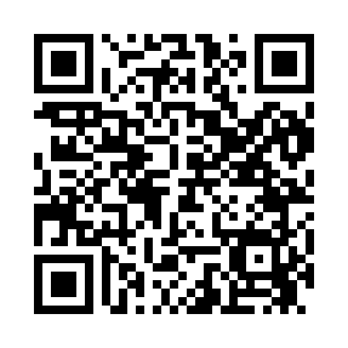
Prayer times for Bass Harbor, Maine, USA
Mon 1 Jul 2024 - Wed 31 Jul 2024
High Latitude Method: Angle Based Rule
Prayer Calculation Method: Islamic Society of North America
Asar Calculation Method: Shafi

Date | Day | Fajr | Sunrise | Dhuhr | Asr | Maghrib | Isha
1 | Mon | 3:02 | 4:54 | 12:37 | 4:45 | 8:21 | 10:12
2 | Tue | 3:03 | 4:54 | 12:38 | 4:45 | 8:21 | 10:12
3 | Wed | 3:04 | 4:55 | 12:38 | 4:45 | 8:20 | 10:11
4 | Thu | 3:05 | 4:56 | 12:38 | 4:45 | 8:20 | 10:11
5 | Fri | 3:06 | 4:56 | 12:38 | 4:45 | 8:20 | 10:10
6 | Sat | 3:07 | 4:57 | 12:38 | 4:45 | 8:19 | 10:09
7 | Sun | 3:08 | 4:58 | 12:38 | 4:45 | 8:19 | 10:08
8 | Mon | 3:09 | 4:58 | 12:39 | 4:45 | 8:18 | 10:08
9 | Tue | 3:10 | 4:59 | 12:39 | 4:45 | 8:18 | 10:07
10 | Wed | 3:11 | 5:00 | 12:39 | 4:45 | 8:17 | 10:06
11 | Thu | 3:13 | 5:01 | 12:39 | 4:45 | 8:17 | 10:05
12 | Fri | 3:14 | 5:02 | 12:39 | 4:45 | 8:16 | 10:04
13 | Sat | 3:15 | 5:02 | 12:39 | 4:45 | 8:16 | 10:02
14 | Sun | 3:17 | 5:03 | 12:39 | 4:44 | 8:15 | 10:01
15 | Mon | 3:18 | 5:04 | 12:39 | 4:44 | 8:14 | 10:00
16 | Tue | 3:19 | 5:05 | 12:40 | 4:44 | 8:14 | 9:59
17 | Wed | 3:21 | 5:06 | 12:40 | 4:44 | 8:13 | 9:58
18 | Thu | 3:22 | 5:07 | 12:40 | 4:44 | 8:12 | 9:56
19 | Fri | 3:24 | 5:08 | 12:40 | 4:44 | 8:11 | 9:55
20 | Sat | 3:25 | 5:09 | 12:40 | 4:43 | 8:10 | 9:54
21 | Sun | 3:27 | 5:10 | 12:40 | 4:43 | 8:09 | 9:52
22 | Mon | 3:28 | 5:11 | 12:40 | 4:43 | 8:08 | 9:51
23 | Tue | 3:30 | 5:12 | 12:40 | 4:43 | 8:07 | 9:49
24 | Wed | 3:31 | 5:13 | 12:40 | 4:42 | 8:06 | 9:48
25 | Thu | 3:33 | 5:14 | 12:40 | 4:42 | 8:05 | 9:46
26 | Fri | 3:35 | 5:15 | 12:40 | 4:42 | 8:04 | 9:44
27 | Sat | 3:36 | 5:16 | 12:40 | 4:41 | 8:03 | 9:43
28 | Sun | 3:38 | 5:17 | 12:40 | 4:41 | 8:02 | 9:41
29 | Mon | 3:39 | 5:18 | 12:40 | 4:41 | 8:01 | 9:39
30 | Tue | 3:41 | 5:19 | 12:40 | 4:40 | 8:00 | 9:38
31 | Wed | 3:43 | 5:20 | 12:40 | 4:40 | 7:58 | 9:36
Prayer times provided by https://www.salahtimes.com

